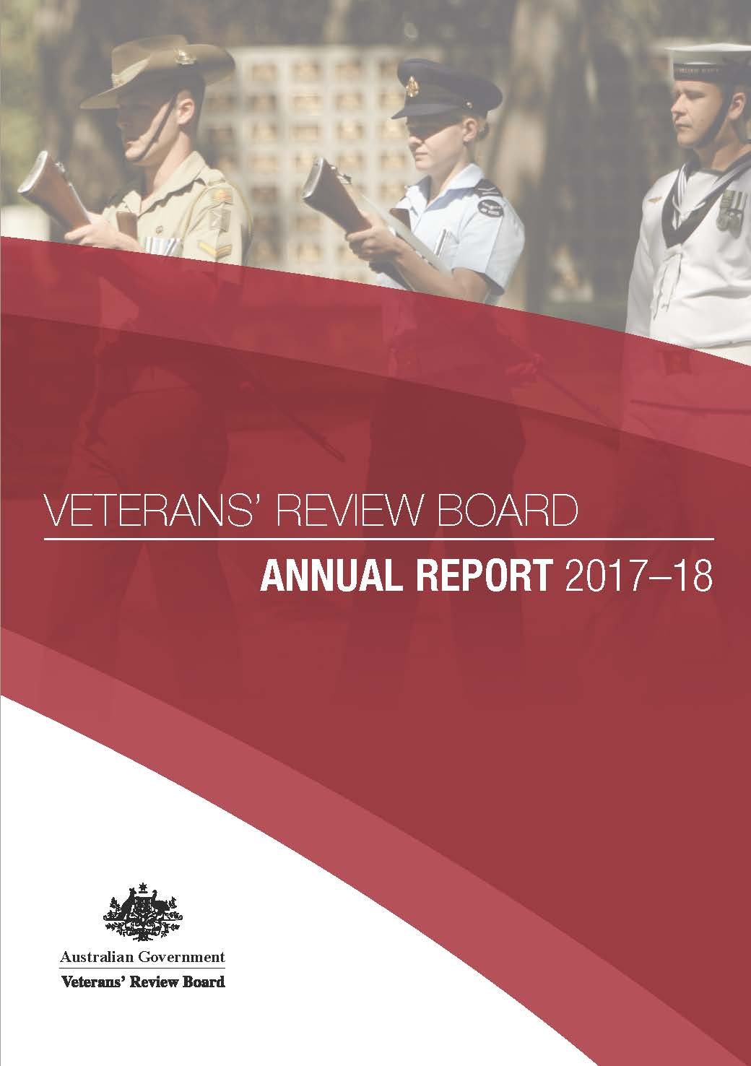

Veterans’ Review Board Annual Report

2017-2018

Published by the Veterans’ Review Board

Cover images courtesy of the Australian Government Department of Defence

© Commonwealth of Australia 2018

ISSN 0-818-0679

This work is copyright. Apart from any use permitted under the *Copyright Act 1968*, no part may be reproduced by any process without prior written permission from the Commonwealth available from the Veterans’ Review Board and inquiries concerning reproduction and rights should be addressed to the’ Review Board by email contact@vrb.gov.au or www.vrb.gov.au.

Publication no. P03708

Contact Information

The Principal Member is responsible for the VRB’s operations. The Registrar in each State is responsible to the National Registrar for arranging the VRB’s day to day business. Registry addresses and the names of those who can assist with enquiries or requests for information are:

|  |  |
| --- | --- |
| National Registry Level 2, Building B Centennial Plaza 280 Elizabeth Street Surry Hills NSW 2010 National Registrar Katrina Harry Information Officer Mark Huthnance Phone: (02) 9213 8631 Fax: (02) 9211 3074  Information about the VRB is available on the Internet. The VRB’s Internet address is: www.vrb.gov.au.  This annual report can be found online at http://www.vrb.gov.au/publications.html  VRB email: contact@vrb.gov.au South-Eastern RegistrySydney Office Level 2, Building B Centennial Plaza 280 Elizabeth Street Surry Hills NSW 2010  Telephone: Local: (02) 9213 8631 City: 1300 550 460 Country: 1800 550 460 Fax: (02) 9211 3074 | Melbourne Office 11th Floor 300 La Trobe Street Melbourne VIC 3000  Telephone: Local: (03) 9602 8000 Hobart: (03) 6221 6646 City: 1300 550 460 Country: 1800 550 460 Fax: (03) 9602 1496 North-Western and South Australian RegistryBrisbane Office Level 8, NAB Place 259 Queen Street Brisbane QLD 4000  Telephone: Local: (07) 3815 9250 City: 1300 550 460 Country: 1800 550 460 Fax: (07) 3815 9221 |

The Hon Darren Chester  
Minister for Veterans’ Affairs  
Parliament House  
CANBERRA ACT 2600

Dear Minister

In accordance with subsection 215(4) of the *Veterans’ Entitlements  
Act 1986*, I present my report on the operations of the Veterans’  
Review Board for the year ending 30 June 2018.

This report has been prepared in accordance with the Requirements  
for Departmental Annual Reports issued by the Department of the  
Prime Minister and Cabinet, to the extent that they are relevant to the  
Board’s operations.

Yours sincerely,

Jane Anderson  
Principal Member

28 September 2018

CONTENTS

Part 1 – Principal Member’s Report 2

Part 2 – The role of the VRB 6

Reviewable decisions under VEA and MRCA 7

The VRB at a glance 2017–18 11

Membership of the VRB as at 30 June 2018 12

Part 3 – Workload and Performance Report 16

Part 4 – Management and Accountability 46

Appendix 1 56

Appendix 2 58

Appendix 3 59

Appendix 4 61

Appendix 5 67

Appendix 6 71

Appendix 7 74



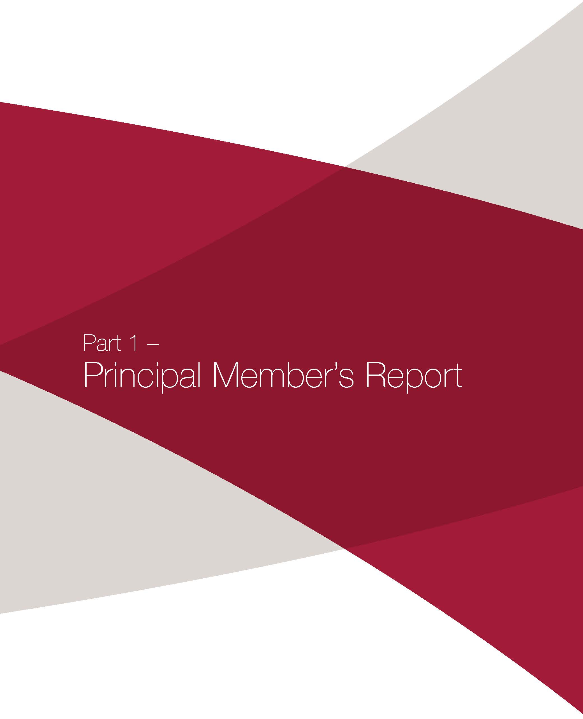

# Part 1 – Principal Member’s Report

***“A veteran’s right to be heard”***

In my first term as Principal Member, I am privileged to be leading the VRB as it continues its transformation journey and commitment to veteran centric reform.

In 2017–18, the VRB saw a steady uptake of matters coming before it for review. During this period, 2923 applications for review were lodged; the highest number since 2013–14.

Significantly, the VRB’s Alternative Dispute Resolution (ADR) program has now been rolled-out to all VRB locations in Australia, with the exception of Queensland, where it will be introduced following the implementation of the VRB’s new case management system.

The results of the VRB’s ADR program are impressive. During 2017–18, 82.6% of cases referred to an ADR process were finalised without the need for a hearing on average in 4.5 months. In addition, ADR played a vital role in assisting the VRB to reduce the average time taken to finalise applications by 5.5% during the financial year.

The VRB continues to be agile and responsive, making use of its diverse and flexible range of ADR mechanisms, each aimed at assisting veterans in the efficient resolution of their applications, and enabling them to have more control over the outcomes. The learnings of ADR have also been brought into VRB hearings, with the launch of an oral reasons trial in mid-2018. The trial encourages VRB members to give their decision and reasons on the day of a veteran’s hearing; thereby streamlining the review process and delivering results to veterans quickly and informally.

In 2017-18, the VRB was an active participant in various external reviews regarding the system of veterans’ entitlements and compensation, and the future and direction of veterans’ advocacy and support services. As part of its contribution to this latter review, the VRB has welcomed and encouraged the observation of VRB ADR events as well as hearings before 3-member panels.

The VRB continues to maintain positive and constructive relationships with the veteran and ex-service communities. A series of advocates’ forums were held over the financial year, providing opportunities for close and continuing dialogue with those representing veterans in their appeals.

As well, the VRB has been working closely with the Department of Veterans’ Affairs. The Department’s support for VRB projects and initiatives has enabled the VRB to trial and collaborate on new reforms aimed at improving its services for veterans and all of the VRB’s users.

I look forward to reporting on the VRB’s operations next year, which will see the VRB continue on its pathway of reform. Further significant achievements are anticipated, including the full roll-out of the VRB’s ADR program across Australia, and the implementation of a new case management system with an online lodgement system to enable veterans and advocates to easily and quickly upload documents and check on the status of their appeals.

The VRB’s continuing success is made possible by the work and efforts of its staff and members throughout Australia. Their ability to embrace change and be part of the VRB’s transformation speaks to their dedication and commitment to the interests of veterans and the value of modern and responsive merits review.

Jane Anderson  
Principal Member  
Veterans’ Review Board

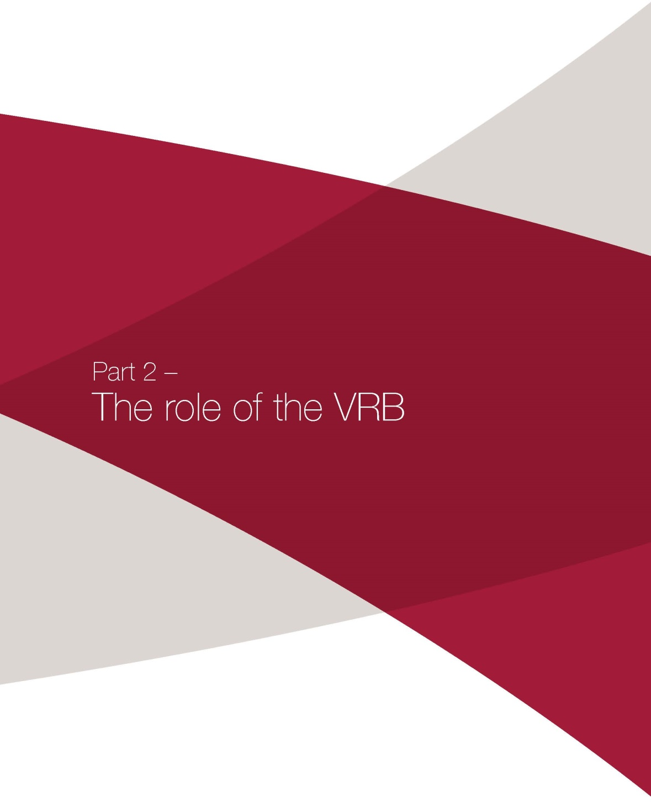

# Part 2 – The role of the VRB

The Veterans’ Review Board (VRB) is a statutory body whose role is to provide independent merits review.

The VRB is not a court, but a specialist high volume tribunal. Merits review means the VRB makes a fresh decision that it considers is the correct or preferable decision in all the circumstances. In doing so, the VRB exercises the same statutory powers, and is subject to the same limitations, as the decision-maker whose decision it is reviewing.

Pursuant to section 133A of the *Veterans’ Entitlements Act 1986* (VEA) the VRB aims to conduct merits review in a manner that is fair, just, economical, informal and quick.

The VRB was established by the *Repatriation Legislation Amendment Act 1984* and began operations on 1 January 1985. It was continued in existence by the VEAwhich came into effect on 22 May 1986. Since then the VRB’s operations have been governed by the VEA.

In conferring additional jurisdiction on the VRB, the *Military Rehabilitation and Compensation Act 2004* (the MRCA) applies provisions of the VEA with some modifications. This means that the VRB operates under the VEA, as modified, when deciding matters under the MRCA or the *Military Rehabilitation and Compensation (Consequential and Transitional Provisions) Act 2004*.

The VEA and the MRCA have now been amended by the *Veterans’ Affairs Legislation Amendment (Mental Health and Other Measures) Act 2014* which received Royal Assent on 30 June 2014. The amendments allowed for a full suite of Alternative Dispute Resolution powers as well as improved case management, administrative and business procedures for the Board.

The VRB has a General Practice Direction in place which sets out the procedure to be adopted for all applications for review before the Board. It is designed to assist the Board in managing cases with the aim that they be finalised within 12 months of lodgement.

The VRB is a part of the governmental machinery for the delivery of repatriation benefits to veterans and their dependants, and rehabilitation and compensation to members and former members of the Australian Defence Force (ADF) and their dependants. The principal components of the system are:

* the Department of Veterans’ Affairs
* the Repatriation Commission
* the Military Rehabilitation and Compensation Commission (MRCC)
* the VRB
* the Administrative Appeals Tribunal.

Although the VRB comes within the Minister for Veterans’ Affairs portfolio and for administrative purposes is included as a sub-program in the Department of Veterans’ Affairs, it is an independent statutory authority. The Minister has no statutory power of direction over the VRB.

### REVIEWABLE DECISIONS

The VRB does not have a general power to review decisions made under the VEA or MRCA. As a statutory tribunal it has only those powers given to it by legislation. The VRB must be able to identify a specific provision that authorises it to make a particular decision or take a particular action. Each decision must relate to a prior decision –the decision under review. The VRB substitutes its own decision for the decision it is reviewing if it thinks the decision should be changed. It makes a new decision in place of the previous decision. In substituting that for the original decision, the VRB may exercise all the powers and discretion that are conferred on the Repatriation Commission, the MRCC or a service chief. The legislative provisions concerning decisions or determinations that the Board has jurisdiction to review are set out below.

## Reviewable decisions under VEA and MRCA

|  |
| --- |
| ***Veterans’ Entitlements Act 1986*** |

|  |  |  |  |  |
| --- | --- | --- | --- | --- |
| Claim for pension under section 14 |  | Application for  increase in pension  under section 15 |  | Application for  Attendant Allowance  under section 111 |

|  |  |  |
| --- | --- | --- |
| **Section concerning the matter** | **Section under which determined** | **Decision** |
| 14 | 19 | Claim for disability pension for injury or disease |
| 14 | 19 | Claim for war widow(er)’s or orphan’s pension for death |
| 15 | 19 | Application for increase in disability pension |
| 98, 111 | 98 | Application for Attendant Allowance |

|  |
| --- |
| ***Military Rehabilitation and Compensation Act 2004*** |

|  |  |  |  |  |  |  |  |  |  |  |
| --- | --- | --- | --- | --- | --- | --- | --- | --- | --- | --- |
| Liability |  | Rehabilitation |  | Compensation for permanent impairment |  | Compensation for incapacity for work |  | Compensation for dependants |  | Compensation for treatment, allowances, debts |

| **Section concerning the matter** | **Section under which determined** | **Determination** |
| --- | --- | --- |
| **Chapter 2** |  | **Accepting liability** |
| 23 | 333 | Liability for service injury or disease |
| 24 | 333 | Liability for service death |
| **Chapter 3** |  | **Rehabilitation** |
| 44 | 44 | Whether to carry out an assessment for rehabilitation |
| 45 | 45 | Require a person to undergo an examination |
| 48 | 48 | Payment of costs reasonably incurred in connection with an examination |
| 51 | 51 | Whether the person is to undertake a rehabilitation program |
| 51 | 51 | Content of a rehabilitation program |
| 53 | 53 | Cessation or variation of a rehabilitation program |
| 58 | 333 | Whether an alteration, aid of appliance is reasonably priced |
| 58 | 333 | Amount of compensation for alteration, aid or appliance |
| 61 | 61 | Assist the person in finding suitable work |
| 64 | 64 | Appointment of a case manager |
| **Chapter 4** |  | **Compensation for members and former members** |
| 68 | 333 | Whether the person suffers an impairment that is permanent and stabilised |
| 68 | 333 | Degree of impairment |
| 68 | 333 | Date on which the person became entitled to compensation under s68 |
| 71 | 33 | Additional compensation |
| 74 | 333 | The effect on lifestyle |
| 75 | 333 | Interim compensation |
| 78 | 78 | Whether to extend the choice period |
| 82 | 333 | Amount of compensation for financial advice |
| 89 | 333 | Amount of compensation for incapacity for service or work for members |
| 118 | 333 | Amount of compensation for incapacity for service or work for former members |
| 201 | 201 | Whether to extend the choice period |
| 203 | 333 | Whether to receive special rate disability pension |
| 206 | 333 | Amount of compensation for financial advice |
| 212 | 333 | Compensation under the Motor Vehicle Compensation Scheme |
| 214 | 333 | Compensation for household services |
| 217 | 333 | Compensation for Attendant care services |
| 221 | 333 | Telephone allowance |
| 226 | 333 | Compensation for loss of, or damage to, medical aids |
| **Chapter 5** |  | **Compensation for dependants** |
| 233 | 333 | Compensation for wholly dependent partners re death |
| 236 | 236 | Whether to extend the choice period |
| 240 | 333 | Amount of compensation for financial advice |
| 242 | 333 | Compensation for wholly dependent partners re permanent impairment and incapacity |
| 244 | 333 | Directions re payment if 2 or more partners entitled to compensation |
| 245 | 333 | Telephone allowance |
| 251 | 333 | Compensation for eligible young person re death |
| 255 | 333 | Compensation for eligible young person re permanent impairment and incapacity |
| 257 | 333 | Directions re payment if 2 or more eligible young persons entitled to compensation |
| 263 | 333 | Compensation for other dependants |
| 267 | 333 | Funeral compensation |
| **Chapter 6** |  | **Treatment** |
| 271 | 276 | Compensation for cost of treatment under Part 2 |
| 273 | 276 | Compensation for cost of treatment before determination of entitlement under Part 3 |
| 291 | 333 | Compensation for cost of accommodation relating to treatment |
| 291 | 291 | Approval of an attendant to accompany the patient |
| 293 | 333 | Compensation for cost of journey relating to treatment |
| 297 | 333 | Compensation for transportation of another person to hospital or mortuary |
| 300 | 333 | Pharmaceutical allowance |
| 315 | 315 | Amount of overpayment to be recovered |
| 316 | 316 | Amount of interest to be recovered |
| 317 | 317 | Reduction of payment because of previous overpayment |
| **Chapter 7** |  | **Claims** |
| 320 | 320 | Approval of person to make claim on behalf of a person |
| 325 | 325 | Needs assessment |
| 328 | 328 | Requiring a medical examination |
| 330 | 330 | Refusal to deal with a claim for failure to comply with obligation notice |
| 333 | 333 | Determination of claim for compensation |
| 340 | 340 | Determination overriding RMA decision concerning a SoP |
| 342 | 342 | Onset date of incapacity for service or work |
| 343 | 343 | Date of death |
| **Chapter 10** |  | **Liabilities apart from the Act** |
| 398 | 398 | Deductions from an award of damages for compensation paid and costs incidental to claim |
| **Chapter 11** |  | **Miscellaneous** |
| 424 | 333 | Special assistance |
| 428 | 428 | Amount of debt that should be written off |
| 429 | 429 | Amount of debt that should be waived |

### APPLYING FOR REVIEW

An application to the VRB has to be in writing and lodged at an office of the Department. An application under the MRCA or an application concerning an entitlement matter under the VEA must be received by the Department within 12 months of notice to the applicant of advice of the decision he or she wishes to challenge (for a VEA entitlement matter, an appeal should be made within 3 months for maximum benefits). An application under the VEA concerning an assessment matter or an Attendant Allowance must be lodged within three months of notice of the decision.

### THE CONDUCT OF REVIEWS

The parties to a review by the VRB are the applicant and the relevant Commission. If the matter concerns rehabilitation of a serving member of the ADF under the MRCA, the relevant service chief may choose to be a party.

An applicant may appoint a representative to assist with his or her case. However, lawyers cannot present a case at hearing (s147(2) of the VEA). Applicants are of course permitted to consult lawyers prior to their hearing. Written legal submissions will be accepted by the VRB for consideration as evidence. Additionally, lawyers are welcome to attend and participate in ADR events before the VRB.

Within six weeks of receiving an application, the relevant Commission must provide the applicant with a report prepared in accordance with s137 of the VEA. That report contains a copy of those documents from the Department’s files that Departmental staff have identified as relevant to the decision or determination under review.

On receiving these documents from the relevant respondent, the VRB writes to the parties seeking written advice about whether they intend to be represented at any ADR event or hearing and whether or not they also wish to attend any ADR event or hearing.

Following the passage of *The Veterans’ Affairs Legislation Amendment (Mental Health and other Measures) Act 2014* the VRB introduced a trial of the full suite of ADR processes in NSW and the ACT from 1 January 2015, applying to all new applications for review that were lodged from this date. Following on from this successful trial the complete ADR program has been introduced for NSW, ACT, VIC, TAS, SA and WA. The ADR program is now fully operational in all locations except QLD. Applicants in QLD can request the ADR processes of case appraisal or neutral evaluation pending the implementation of the complete program in their state.

The ADR model used at the VRB is facilitative. The first mandatory event for all applications in the ADR program is an outreach. An outreach is a conversation that takes place between a Board Conference Registrar and the applicant (and their representative). If an application cannot be resolved at the first outreach, the ADR program has a number of flexible options that can be used to assist in resolving the application quickly and without the need for a full hearing. These include: seeking further information or evidence from the parties (including a s148(6A) request to the respondent), a case appraisal, neutral evaluation or two party conferencing. If a matter has not settled during the ADR program, the parties have the right to proceed to a full hearing.

The VRB is not bound by technicalities or the rules of evidence. Hearings are informal and normally conducted in private. The presiding member determines who may be present and, if requested by the applicant, may permit a hearing to take place in public. Although not usual, witnesses may be summoned and evidence may be taken on oath or affirmation. All hearings are recorded to provide an accurate record of what is said. Copies of the recordings are made available free of charge to the parties on request, or the original recording may be listened to at the VRB’s premises. The recording is retained for two years and then destroyed in accordance with the *Archives Act 1983*.

Issues are decided according to the opinion of the majority of members constituting the VRB panel. A copy of the decision and reasons of the VRB is mailed to each party, the applicant’s representative and, under the VEA the Department of Veterans’ Affairs or under the MRCA for currently serving members, the relevant service chief.

The VRB decision may affirm, vary or set aside the decision under review. If the decision is to set aside, the VRB must substitute its own decision. The VRB also has a broad power of remittal.

The VRB may adjourn the hearing of a review, either at the request of the parties or of its own volition. Upon an adjournment the VRB may also request the Secretary of the Department of Veterans’ Affairs or the MRCC to seek additional information, reports or evidence for consideration by the VRB. If the Department is requested to provide further information, the cost is met by the Department and not the applicant and/or their representative.

### VISION, PURPOSE AND VALUES

### Our Outcome

Pursuant to section 133A of the VEA, our aim is to provide a means of review that is fair, just, economical, informal and quick in an environment that ensures respect for the service of applicants and dignity in the conduct of proceedings.

### Our Mission

To deliver high quality independent merits review of decisions and determinations in a timely fashion using alternative dispute resolution processes.

### Our Values

The Board seeks to integrate administrative law values of fairness, openness, accessibility and efficiency with high standards of professionalism reflecting independent and impartial minds, respect for the dignity of others, personal integrity and diligence.

## The VRB at a glance 2017–18

|  |  |
| --- | --- |
|  |  |
| Applications lodged | 2923 |
| Applications decided | 2780 |
| Applications on hand | 2480 |
| % of matters set aside | 59.8% |
| % of matters affirmed | 40.2% |
| Average time taken to decide an application (weeks) | 50 |
| % of decided cases where applicant represented | 80.2% |
| Hearings arranged | 1108 |
| Directions hearings arranged | 211 |
| % of decided cases where hearing held | 34.9% |
| % of applications appealed to the AAT | 6.7% |
| Members | 32 |
| Staff (FTE) | 28.5 |
| Cost | $6.03M |

## Membership of the VRB as at 30 June 2018

|  |  |
| --- | --- |
| AUSTRALIAN CAPITAL TERRITORYPart-Time Senior Member: June McPhie Part-Time Services Member: Mark Bornholt Part-Time Member: Josephine Lumb NEW SOUTH WALESPart-Time Senior Member: Robyn Bailey  Jenny D’Arcy  Hilary Kramer  Jillian Moir  Les Young Part-Time Services Member: Simon Hart  Bruce Wood  Warwick Young  Nadine Crimston Part-Time Member: Frank Brown  Christopher Keher  Neville Wyatt VICTORIAPart-Time Senior Member: Robert Douglass  Christopher Wray Part-Time Services Member: Rob Regan Part-Time Member: Sharon Brennan  Sandra Kerr | QUEENSLANDPart-Time Senior Member: Alison Colvin  Tammy Williams Part-Time Services Member: Scott Clark  Christopher Hamilton  Francis Roberts  Iain Whitehouse Part-Time Member: Christopher Austin WESTERN AUSTRALIAPart-Time Senior Member: Gary Barrow Part-Time Services Member: Louise Hunt Part-Time Member: Geoffrey Hourn TASMANIAPart-Time Member: Linda Corbould |

Staff organisational chart as at 30 June 2018

|  |  |
| --- | --- |
| Principal Member Jane Anderson | |
|  |  |
| National Registrar Katrina Harry PSM | |
|  |  |
| National RegistryFinance & Business Services Manager Mark Huthnance Legal & Policy Officer Lynley Gardner Alternative Dispute Resolution Registrar Jane Warmoll Conference Registrar Paul Jones Deputy Conference Registrar David Leeson Alternative Dispute Resolution SupportOfficer Alison Kavanagh  Rhonda Blair Finance & Member Liaison Officer Ariane Mandavy Executive Assistant Glenn Katsoolis | South-East Australia RegistrySouth-East Australia Registrar Louise Povolny South-East Australia Deputy Registrar Rex Nera  7 x Client Service Officers – including 3 contractors (Sydney office) North-West & SA RegistryNorth-West & SA Registrar Andrea Flanagan PSM North-West & SA Deputy Registrar Jodi Ross  6.4 x Client Service Officers – including 1 contractor (Brisbane office) |

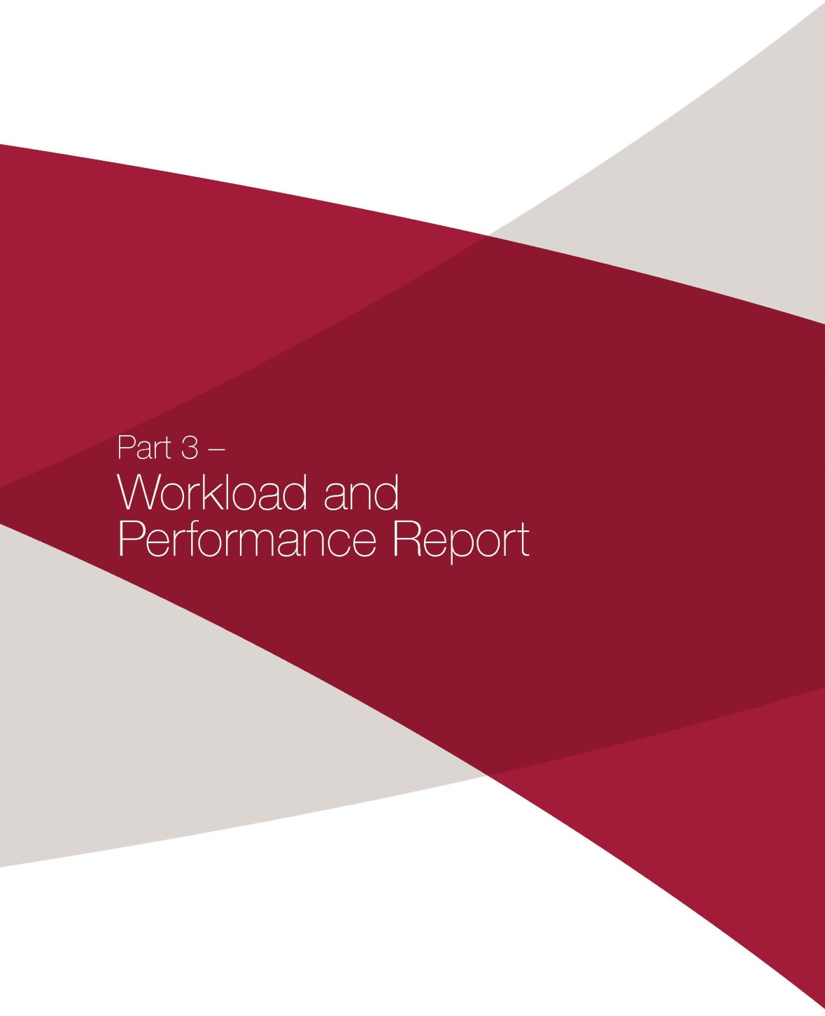

# Part 3 – Workload and Performance Report

The Board contributed to the delivery of repatriation benefits to veterans and their dependants, and rehabilitation and compensation to members and former members of the Australian Defence Force (ADF) and their dependants through the provision of quality and timely reviews of decisions, completing 2780 reviews. The outcomes were favourable to applicants in 59.8 per cent of the matters decided for these reviews.

### OUTCOMES STRUCTURE

Pursuant to section 133A of the VEA, the objective of the VRB is to provide a means of review that is fair, just, economical, informal and quick, in an environment which ensures respect for the service of applicants and dignity in the conduct of proceedings. The VRB measures its performance against this objective using a number of reporting mechanisms including:

Outcome 1: Finalise a high number of applications for review

Outcome 2: High assurance that review decisions are correct

Outcome 3: Complete all process stages under VRB control on a timely basis

Outcome 4: Undertake reviews in a manner that is efficient in resource usage

Outcome 5: Accessible and responsive to the veteran community and stakeholders

### OVERVIEW OF CASE LOAD

During the course of the reporting year, the VRB received 2923 applications, finalised 2780 applications and had 2480 active applications at the end of the year.

### APPLICATIONS LODGED

In the reporting year, 2923 new applications were lodged. This represented an increase of 2.5 per cent. MRCA cases comprised 28.4 per cent of new cases lodged at the VRB in 2016–17; whereas they represented 22.3 per cent of the intake in the previous financial year.

Board applications were predominately received from the major urban areas: 40.8 per cent of applications were lodged in NSW, 34.3 per cent in Queensland, 15.2 per cent in Victoria, 4.4 per cent in Western Australia and 5.3 per cent in South Australia. NSW includes ACT figures, Victoria includes Tasmania figures, and South Australia includes Northern Territory cases.

Graph 1.1: Applications lodged

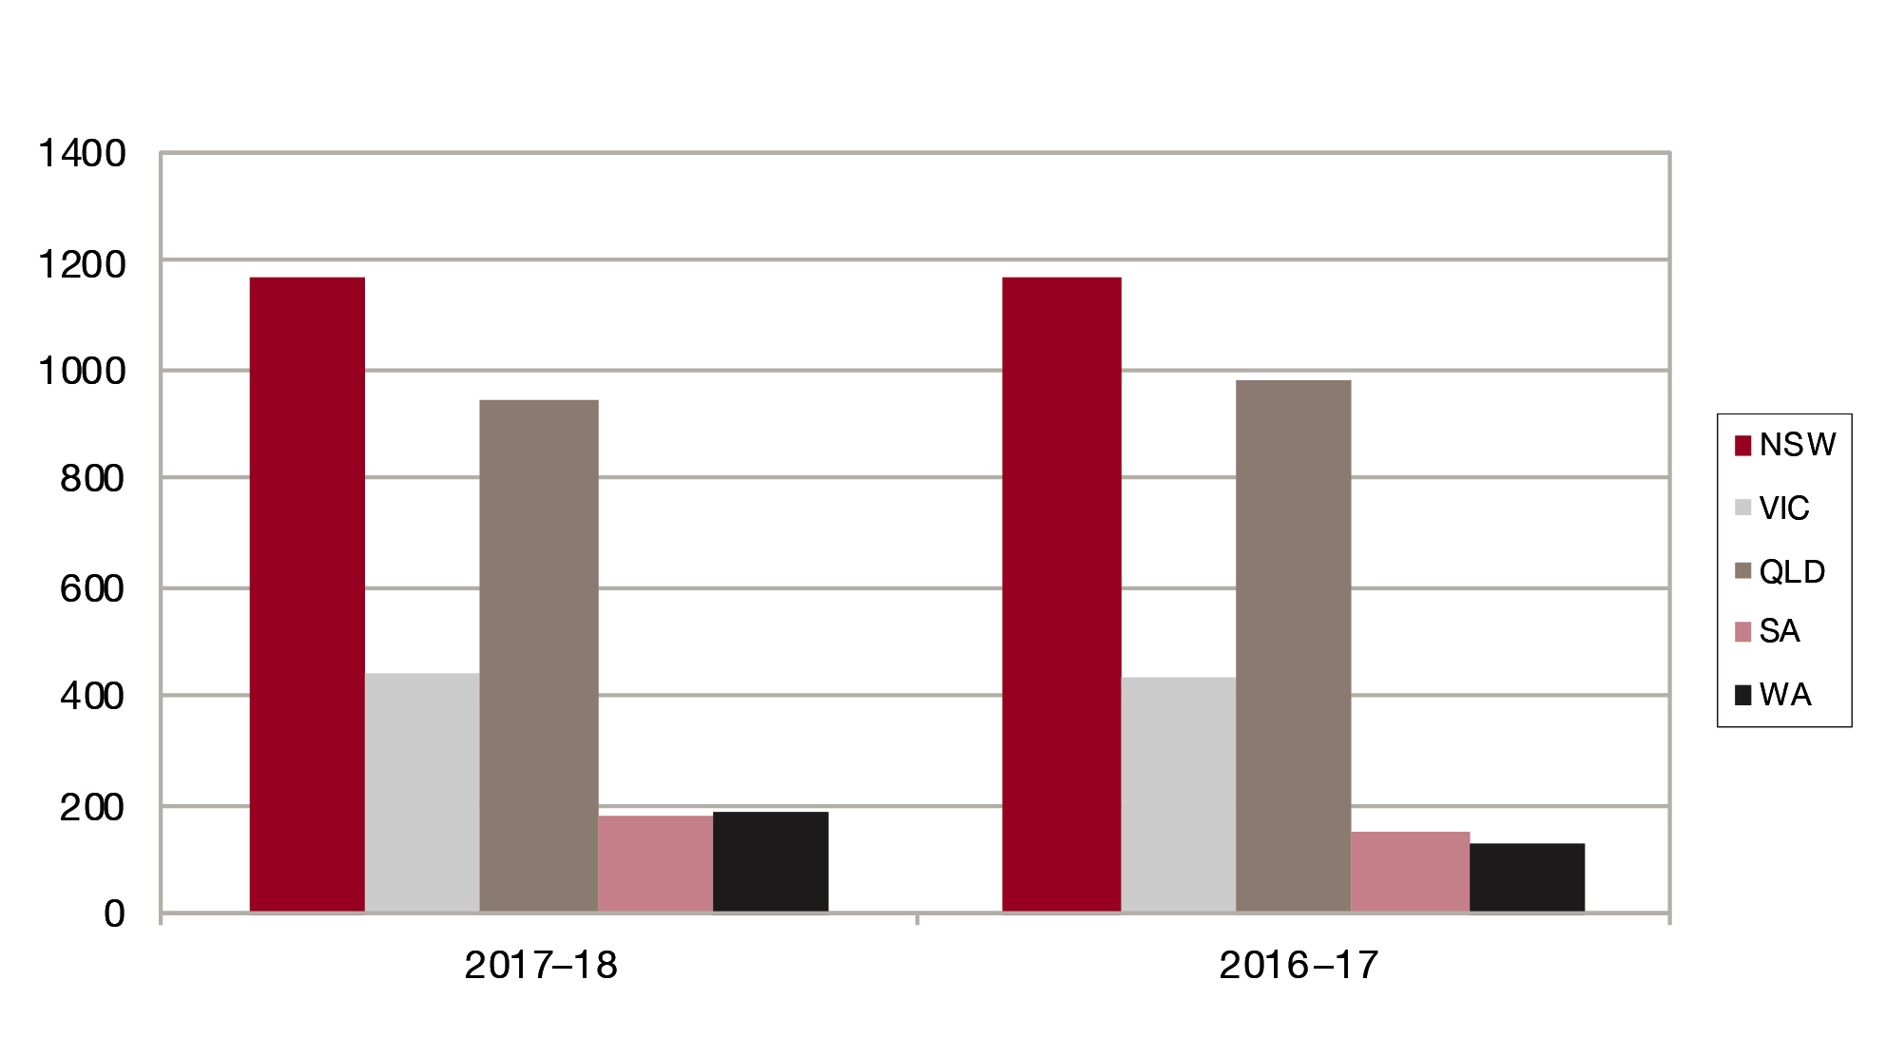

Graph 1.2: Percentage distribution of applications lodged 2017–18

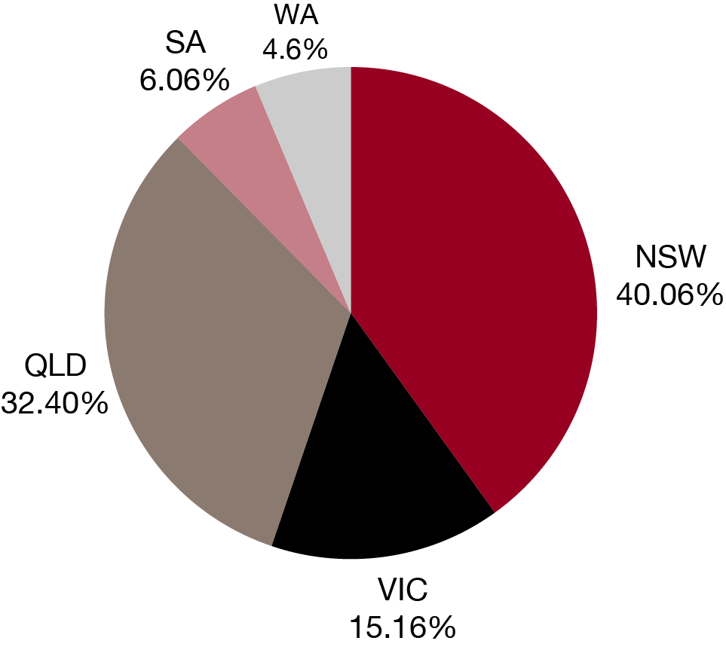

### OUTCOME 1: FINALISE HIGH NUMBERS OF APPLICATIONS

The VRB now has two ways in which it can finalise reviews of decisions:

* applications can be finalised without a hearing during an ADR process, and
* applications can be finalised following a full hearing.

#### Applications finalised by hearing

There were 1108 applications heard in 2017–18: 709 under the VEA and 399 under the MRCA. Applications for review may be finalised by dismissal, withdrawal, by decision of the VRB following a hearing or alternative dispute resolution process.

For this reporting year the Board finalisation and lodgement figures were similar. There were 2780 applications finalised during the year: 1724 under the VEA, and 1056 under the MRCA.

An application may include more than one ‘matter’ to be decided. For example, a claim for several disabilities might have been refused by the relevant Commission; each of these could be a separate matter within the same jurisdiction. Because not all matters belonging to a new application are necessarily recorded when it is registered, the numbers of matters lodged have not been reported. However, by the time of the hearing or finalisation of the application, all of its matters are recorded, thus the numbers of matters heard and finalised have been reported.

There were 4725 matters finalised during the year: 2604 under the VEA and 2121 under the MRCA. Also there were 2540 matters heard in the same period: 1463 under the VEA and 1077 under the MRCA. The reduction in the number of a matters heard was due to the success of the ADR Program in reducing the number of applications that had to be the subject of a Board hearing prior to finalisation.

Graph 1.3: Applications Finalised

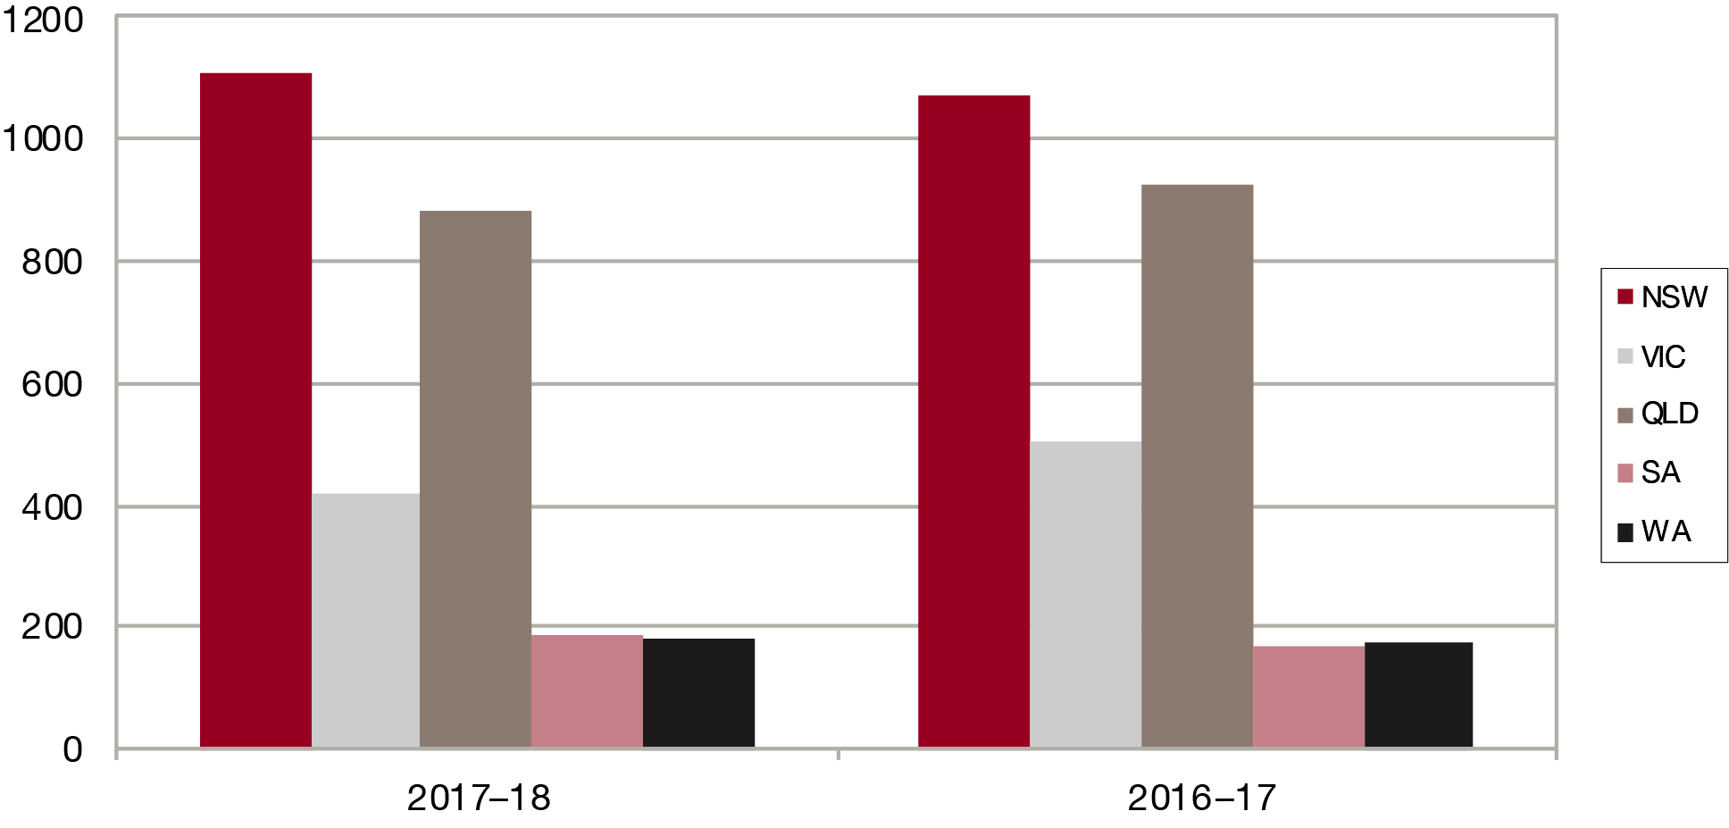

Graph 1.4: Percentage distribution of applications finalised 2017–18

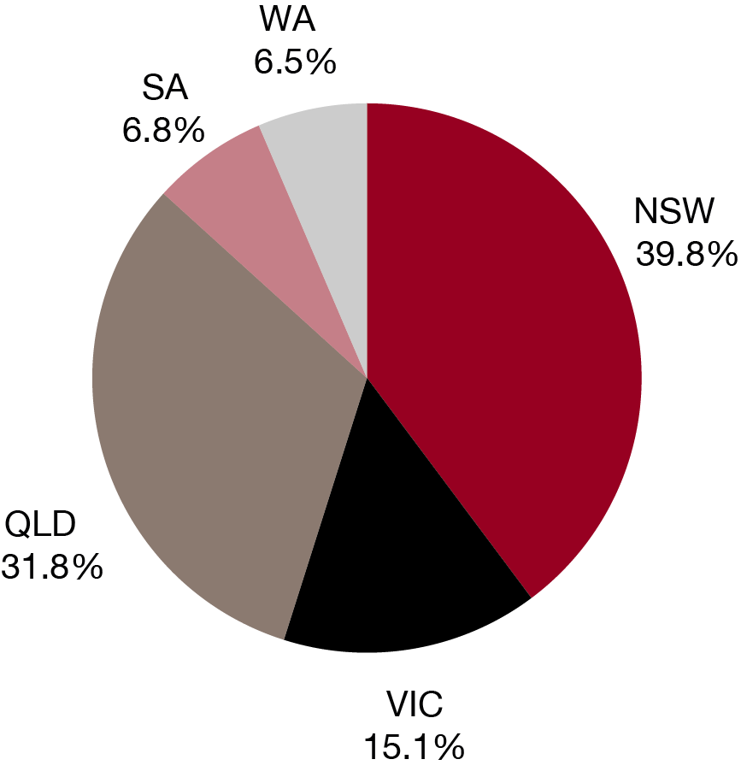

Graph 1.5: Applications finalised by hearing

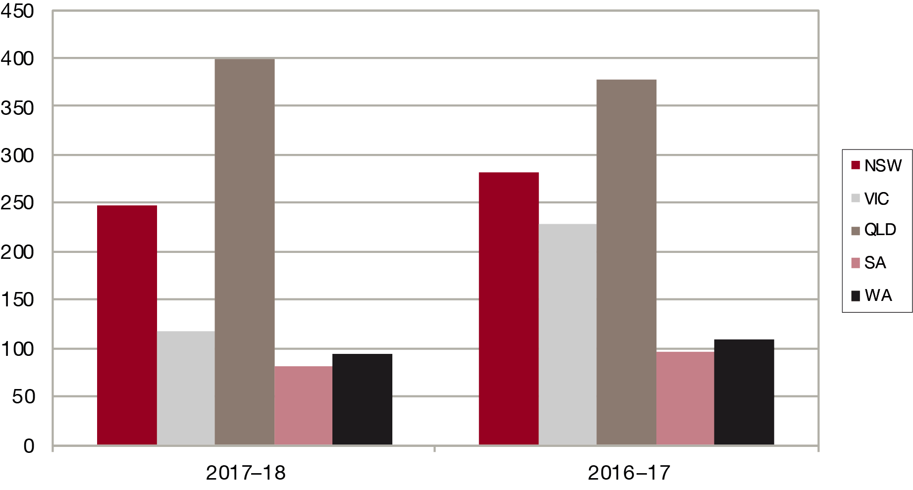

Graph 1.6: Percentage distribution of applications finalised by hearing 2017–18

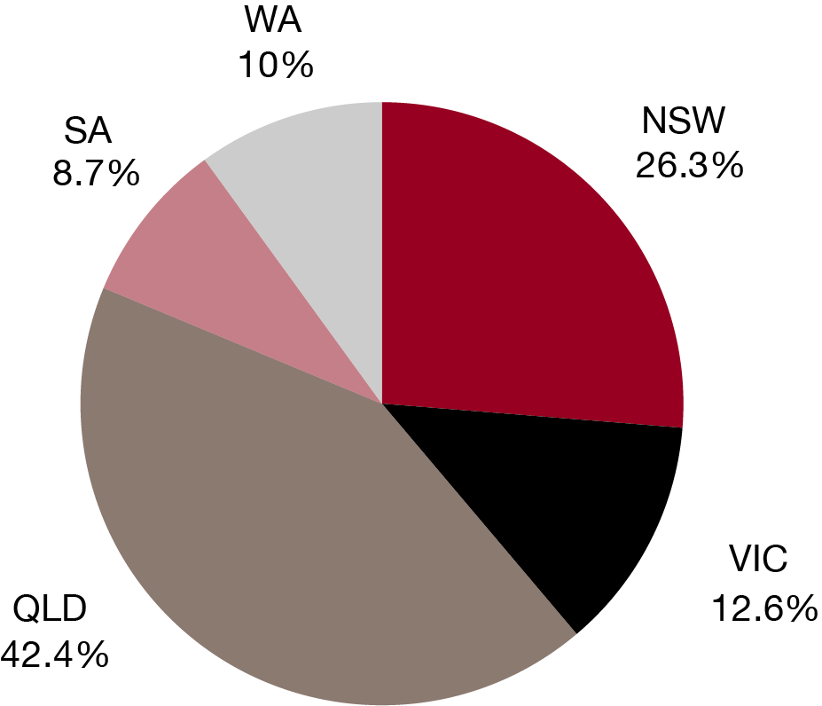

Graph 1.7: Applications heard

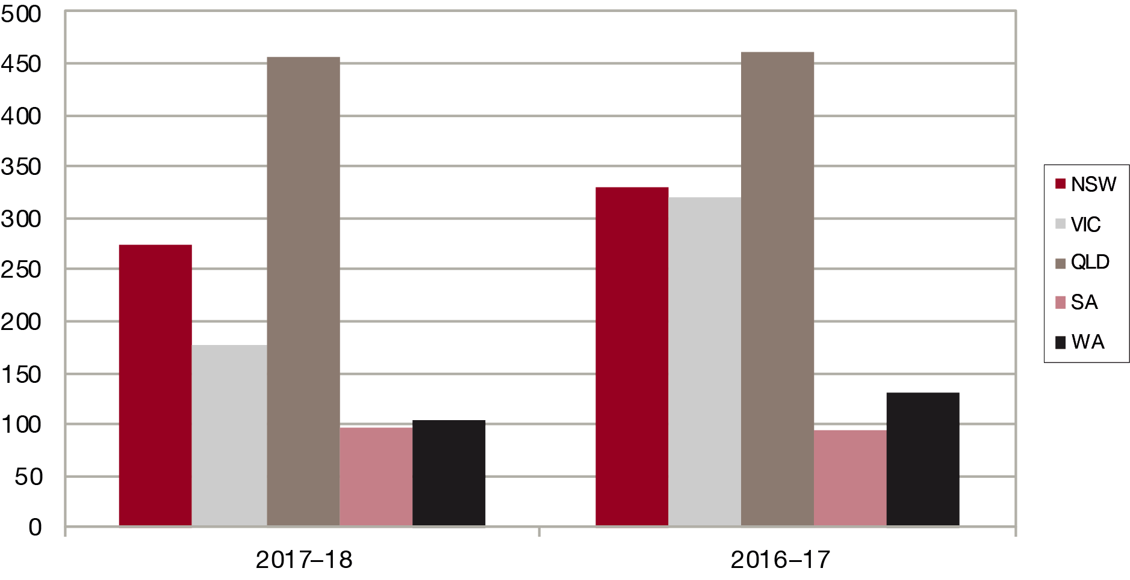

Graph 1.8: Percentage distribution of applications heard 2017–18

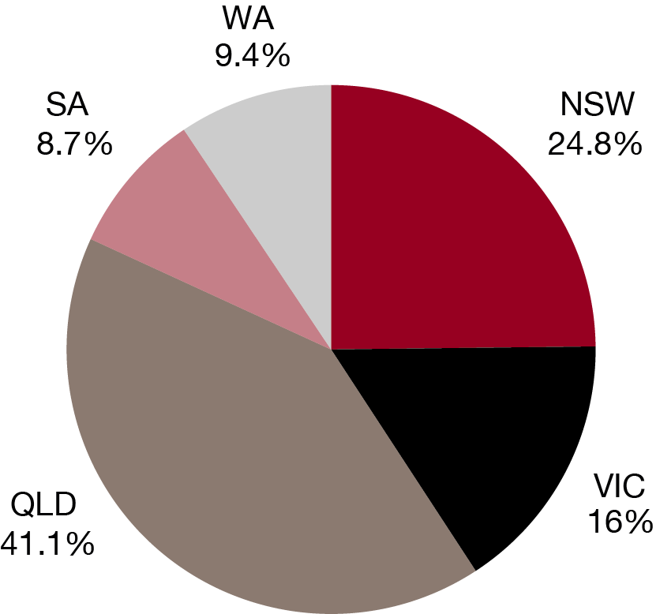

#### Applications finalised without a hearing

Alternative dispute resolution (ADR) describes a range of ways the VRB can help parties resolve their disputes without the need for a full hearing – for example, outreaches, conferences and on papers reviews including case appraisals and neutral evaluations.

ADR is a flexible alternative to traditional VRB hearings and can be less stressful for the people involved, giving parties greater control over the outcome of their disputes. Even when ADR does not resolve a case, it can narrow the issues so that the full hearing takes less time.

During 2017–18, 898 applications, or 82.6% of cases referred to an ADR process were finalised without the need for a hearing. This represents an improvement over the results achieved in 2016–17 when 810 applications, or 64.1% of cases referred to an ADR process were finalised without a Board hearing.

### CURRENT APPLICATIONS

The number of applications current at 30 June 2018 was higher than the end of the previous reporting period by 3.4 per cent. At year’s end, 2480 applications were outstanding: 1457 under the VEA and 1023 under the MRCA.

Graph 1.9: Applications outstanding 30 June 2018

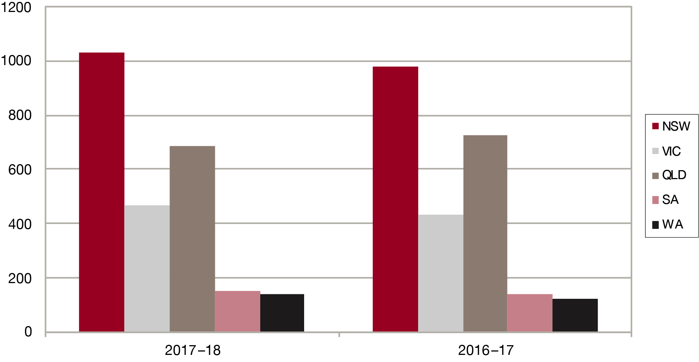

Graph 1.10: Percentage distribution of applications outstanding 30 June 2018

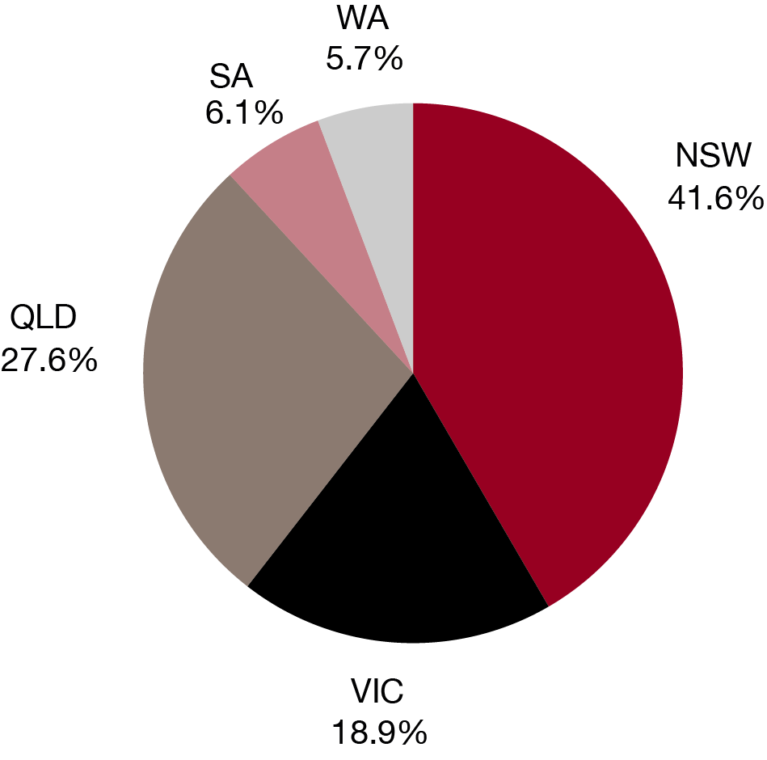

Table 1 below provides more details on the current applications in the reporting year.

|  |  |  |  |  |  |  |  |
| --- | --- | --- | --- | --- | --- | --- | --- |
| Table 1: Applications lodged, finalised, heard and outstanding | | | | | | | |
|  | Year | NSW | VIC | QLD | SA | WA | AUST |
| Applications lodged | 2017–18 | 1171 | 443 | 947 | 177 | 185 | 2923 |
|  | 2016–17 | 1167 | 435 | 983 | 151 | 127 | 2863 |
| Applications finalised | 2017–18 | 1106 | 420 | 885 | 190 | 179 | 2780 |
|  | 2016–17 | 1075 | 502 | 924 | 166 | 177 | 2844 |
| Matters finalised | 2017–18 | 1907 | 727 | 1457 | 333 | 299 | 4723 |
|  | 2016–17 | 1983 | 1009 | 1626 | 273 | 312 | 5203 |
| Apps finalised by hearing | 2017–18 | 247 | 118 | 399 | 82 | 94 | 940 |
|  | 2016–17 | 282 | 229 | 377 | 96 | 109 | 1093 |
| Applications heard | 2017–18 | 275 | 177 | 455 | 97 | 104 | 1108 |
|  | 2016–17 | 330 | 321 | 462 | 94 | 132 | 1339 |
| Matters heard | 2017–18 | 630 | 406 | 1044 | 221 | 239 | 2540 |
|  | 2016–17 | 808 | 765 | 901 | 202 | 351 | 3027 |
| Applications outstanding | 2017–18 | 1031 | 468 | 684 | 152 | 142 | 2480 |
|  | 2016–17 | 978 | 431 | 726 | 141 | 121 | 2397 |

### OUTCOME 2: HIGH ASSURANCE THAT DECISIONS ARE CORRECT

A written statement of decisions and reasons is prepared in each case and these are provided to both the applicant and the relevant commission.

The review of a Repatriation Commission decision may involve deciding more than one substantive matter of entitlement and/or assessment. During 2017–18, there was an average of 2.1 matters for each VEA application heard. During 2017–18, decisions concerning 1456 VEA matters were published.

The review of a MRCC determination also usually involves determining more than one substantive matter of liability, compensation, treatment, rehabilitation or other matter. During 2017–18 there were an average of 2.7 matters for each MRCA application heard. In 2017–18, determinations concerning 915 MRCA matters were published.

In this reporting year the Board set aside:

* 61.9 per cent of death matters reviewed
* 53.6 per cent of disability or liability matters reviewed
* 70.4 per cent of assessment or compensation matters.

In total, 59.8 per cent of all matters reviewed were set aside.

The fact that a decision is set aside by the Board is not necessarily a reflection on the quality of the primary decision. Set aside and affirmation rates may vary for a wide variety of reasons. Some of the factors that may have influenced these results include:

* the approach taken by applicants and representatives to the matters on which review will be sought
* the extent to which intervention occurs by the relevant Commission under s31 of the VEA or s347 of the MRCA
* the adequacy of information presented to primary decision-makers
* the nature and extent of new material presented on review
* changes to Statements of Principles between the primary decision and that made by the Board, or a shift in focus by the applicant to a different factor in the Statement of Principles
* changes in an applicant’s degree of incapacity or impairment between the date of the decision under review and the date of the final hearing at the VRB in an assessment or compensation matter.

If a VRB panel reviews an application and receives further oral evidence during a hearing, issues might need clarification or further investigation. Alternatively, the applicant might need a further opportunity to, consistent with procedural fairness, assess his or her position. In light of these considerations the VRB may adjourn a hearing under review. More information on the Board’s adjournments can be found under Outcome 3.

The outcomes of the published decisions under the VEA and determinations under the MRCA are shown in Table 2 and Graphs 2.1 to 2.4. In this table ‘disability matters’ applies to applications under the VEA, while its equivalent under the MRCA is ‘liability’; ‘assessment matters’ applies to applications under the VEA, while under the MRCA matters other than liability, such as permanent impairment, treatment and rehabilitation are referred to as ‘compensation’.

| Table 2: Outcome of published decisions and determinations (set aside and affirmed) | | | | | | | |
| --- | --- | --- | --- | --- | --- | --- | --- |
|  | Year | NSW | VIC | QLD | SA | WA | AUST |
| Total death | 2017–18 | 53 | 17 | 32 | 9 | 7 | 118 |
| 2016–17 | 105 | 28 | 47 | 12 | 16 | 208 |
| Set aside death | 2017–18 | 46 | 9 | 9 | 5 | 4 | 73 |
| 86.8% | 52.9% | 28.1% | 55.6% | 57.1% | 61.9% |
| 2016–17 | 92 | 14 | 16 | 8 | 10 | 140 |
| 87.6% | 50% | 34% | 66.7% | 62.5% | 67.3% |
| Affirmed death | 2017–18 | 7 | 8 | 23 | 4 | 3 | 45 |
| 13.2% | 47.1% | 71.9% | 44.4% | 42.9% | 38.1% |
| 2016–17 | 13 | 14 | 31 | 4 | 6 | 68 |
| 12.4% | 50% | 66% | 33.3% | 37.5% | 32.7% |
| Total disability/liability | 2017–18 | 518 | 233 | 454 | 101 | 130 | 1436 |
| 2016–17 | 569 | 317 | 362 | 128 | 148 | 1524 |
| Set aside disability/ liability | 2017–18 | 367 | 131 | 155 | 55 | 61 | 769 |
| 70.8% | 56.2% | 34.1% | 54.5% | 46.9% | 53.6% |
| 2016–17 | 387 | 129 | 124 | 66 | 41 | 747 |
| 68% | 40.7% | 34.3% | 51.6% | 27.7% | 49% |
| Affirmed disability/liability | 2017–18 | 151 | 102 | 299 | 46 | 69 | 667 |
| 29.2% | 59.3% | 65.9% | 45.5% | 53.1% | 46.4% |
| 2016–17 | 182 | 188 | 238 | 62 | 107 | 777 |
| 32% | 59.3% | 65.7% | 48.4% | 72.3% | 51% |
| Total assessment/ compensation | 2017–18 | 292 | 131 | 265 | 65 | 64 | 817 |
| 2016–17 | 266 | 90 | 194 | 43 | 32 | 625 |
| Set aside assessment/ compensation | 2017–18 | 224 | 108 | 156 | 45 | 42 | 575 |
| 76.7% | 82.4% | 58.9% | 69.2% | 65.6% | 70.4% |
| 2016–17 | 194 | 44 | 101 | 24 | 14 | 377 |
| 72.9% | 48.9% | 52.1% | 55.8% | 43.8% | 60.3% |
| Affirmed assessment/ compensation | 2017–18 | 68 | 23 | 109 | 20 | 22 | 242 |
| 23.3% | 17.6% | 41.1% | 30.8% | 34.4% | 29.6% |
| 2016–17 | 72 | 46 | 93 | 19 | 18 | 248 |
| 27.1% | 51.1% | 47.9% | 44.2% | 56.2% | 39.7% |
| Total all matters | 2017–18 | 863 | 381 | 751 | 175 | 201 | 2371 |
| 2016–17 | 940 | 434 | 603 | 183 | 196 | 2356 |
| Set aside all matters | 2017–18 | 637 | 248 | 320 | 105 | 107 | 1417 |
| 73.8% | 65.1% | 42.6% | 60% | 53.2% | 59.8% |
| 2016–17 | 671 | 185 | 239 | 97 | 64 | 1256 |
| 71.4% | 42.5% | 39.6% | 53.3% | 39.4% | 53.3% |
| Affirmed all matters | 2017–18 | 226 | 133 | 431 | 70 | 94 | 954 |
|  |  | 26.2% | 34.9% | 57.4% | 40% | 46.8% | 40.2% |
|  | 2016–17 | 269 | 250 | 364 | 85 | 132 | 1100 |
|  |  | 28.6% | 57.5% | 60.4% | 46.7% | 67.4% | 46.7% |

Graph 2.1: Death matters set aside rates

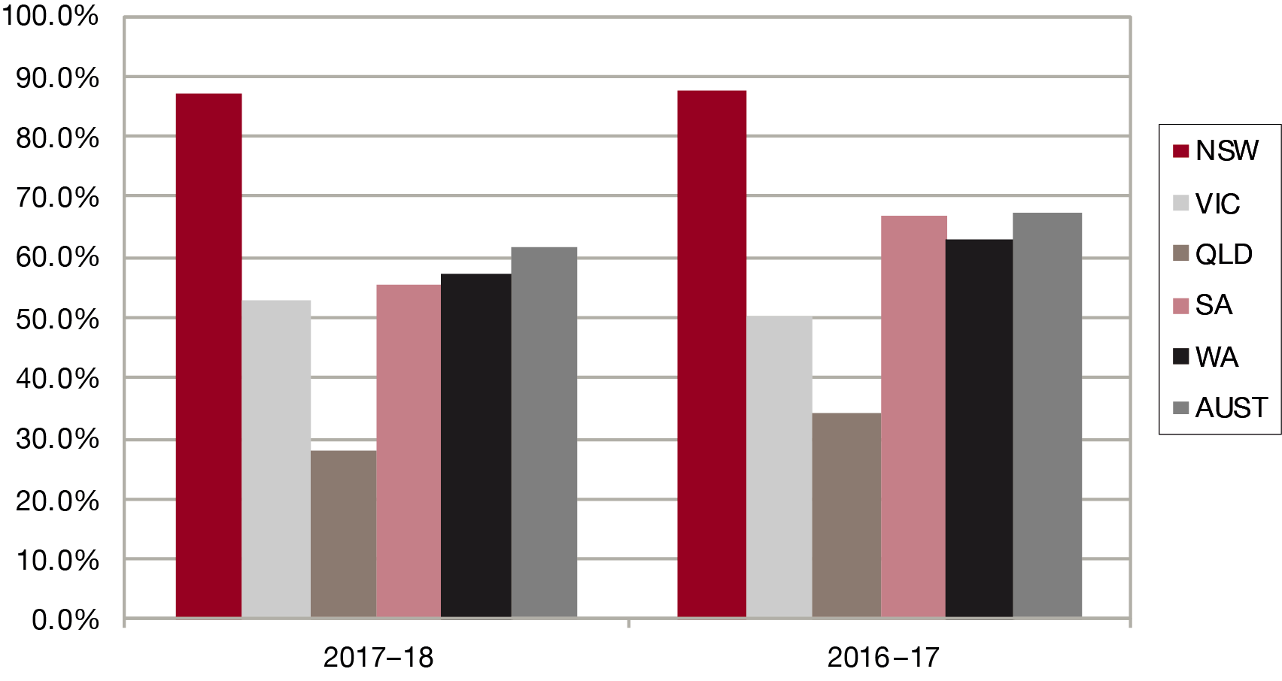

Graph 2.2: Disability/liability matters set aside rates

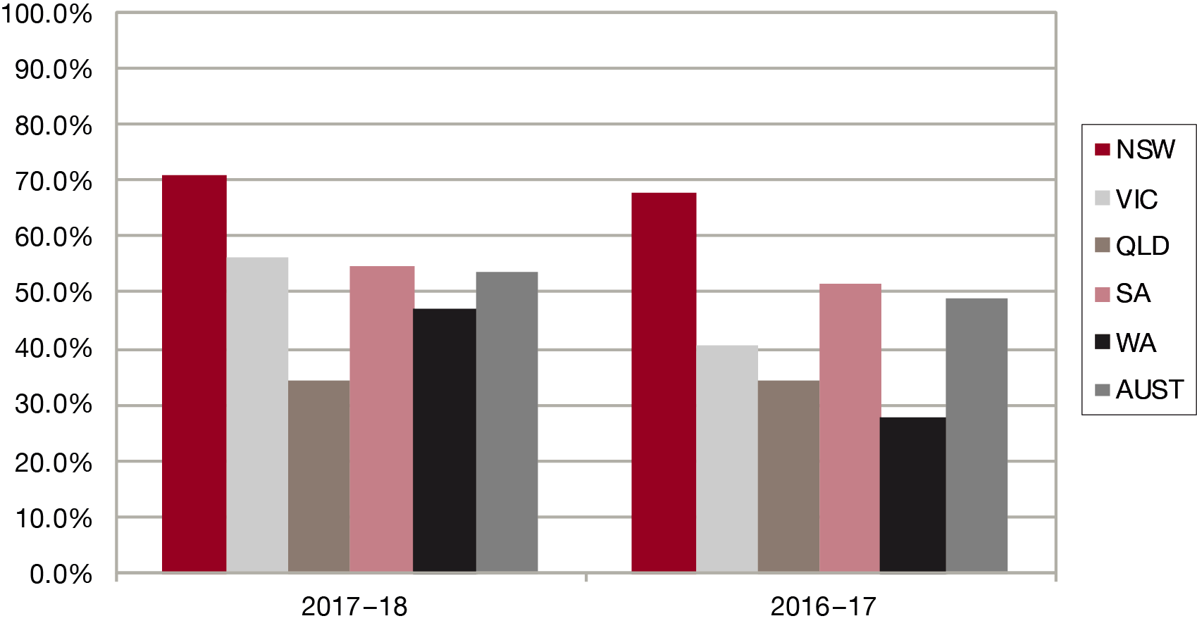

Graph 2.3: Assessment/compensation matters set aside rates

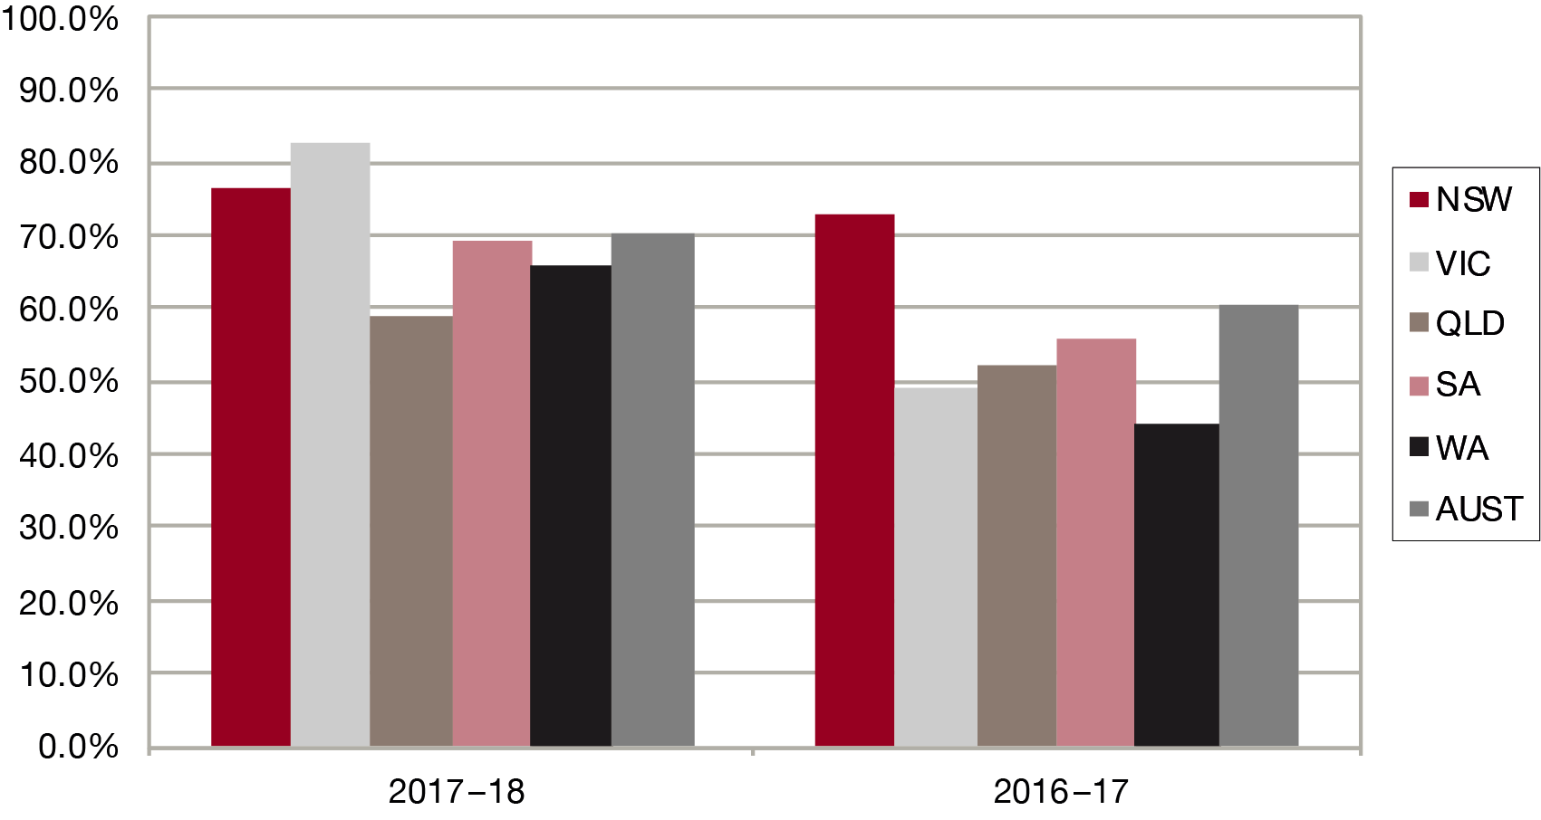

Graph 2.4: All matters set aside rates

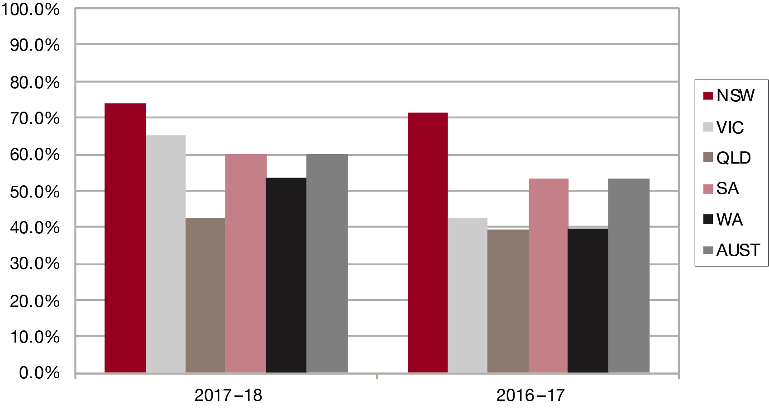

Internal scrutiny of decisions and, in part, reference to the results of applications to the Administrative Appeals Tribunal (AAT) and the courts enables some measurement in relation to ensuring the VRB’s decisions are correct.

### FURTHER REVIEW

VRB decisions are subject to merits review by the AAT. The VRB is not a party to the proceedings before the AAT.

During 2017–18 the VRB was notified of the lodgement of 187 applications for review by the AAT of matters involving VRB decisions.

The table below sets out the number and the percentage of decisions which have been the subject of applications for review by the AAT. The application rate is estimated by comparing the number of applications lodged with the AAT with the number of applications finalised by VRB decisions made at hearings. It should be noted, however, that applications to the AAT are not necessarily made in the same financial year as the VRB decisions although the great majority are.

|  |  |  |
| --- | --- | --- |
| Table 3: Applications for review by the AAT |  |  |
|  | **2016–17** | **2017–18** |
| Applications for review from VRB decisions | 165 | 187 |
|  | 5.8% | 6.7% |

In the course of 2017–18 the AAT finalised 220 applications for review of decisions of the VRB. Of these, 196 had been made under the VEA and 24 under the MRCA. The tables below set out the outcomes of review by the AAT over the last two years.

|  |  |  |
| --- | --- | --- |
| Table 4: AAT review outcomes |  |  |
|  | **2016–17** | **2017–18** |
| Withdrawn or dismissed | 49.8% | 50.5% |
| Conceded | 22.3% | 28.2% |
| Finalised by hearing | 27.9% | 21.3% |

|  |  |  |
| --- | --- | --- |
| Table 5: Applications for review by the AAT |  |  |
|  | **2016–17** | **2017–18** |
| Affirmed | 39 | 39 |
|  | 66.1% | 33.9% |
| Varied or set aside | 20 | 76 |
|  | 33.9% | 66.1% |

In respect of the VRB decisions that were set aside by the AAT, in the majority of these cases there appears to have been evidence before the AAT that was not before the VRB.

#### Review of MRCA Decisions

During 2017–18 there were 24 matters finalised in the AAT concerning appeals from the VRB under the MRCA. Ten were set aside by consent or varied, one was affirmed by decision of the Tribunal following a hearing, thirteen were withdrawn by the applicant, none were affirmed by consent, none were set aside by decision of the Tribunal following a hearing, and none were dismissed by the Tribunal.

A summary of relevant court decisions are set out in Appendix 1 and other forms of external scrutiny of VRB decisions are outlined in Appendix 2.

### OUTCOME 3: COMPLETE ALL PROCESS STAGES UNDER VRB CONTROL ON A TIMELY BASIS

#### Processing times for non-ADR program cases

Applications for review proceed through a number of stages from lodgement to finalisation. Not all applications necessarily proceed through all stages. While some are primarily under the control of the VRB, others fall largely under the control of DVA or the applicant (or representative). Stages largely under the control of DVA are:

* from receipt of the application by the Department to receipt of the s137 report by the VRB
* while obtaining information requested by the Registrar under s148(6A) of the VEA
* while obtaining information requested by the VRB after adjournment of a hearing under s152 of the VEA.

In 2017–18 the average time taken from lodgement of an application to receipt of a s137 report was 42.8 days. This compares with 51.1 days in 2016–17.

During 2017–18, 950 requests for further information were completed by DVA, with an average time for completion of 128.8 days. Of these, 829 requests had been made by Registrars, with an average time for completion of 123.6 days; and 121 requests had been made following adjournments, with an average time for completion of 164.5 days. These figures compare with 912 requests completed in 2016–17, at an average time of 130 days. Of these, 762 requests had been made by Registrars, at an average time for completion of 121.8 days; and 150 requests had been made following adjournments, at an average time for completion of 171.6 days.

Stages largely under the control of the applicant (or representative) are:

* from sending a s148 notice by the VRB to the applicant to its return
* from sending a Certificate of Readiness (COR) from the VRB to the applicant to its return.

While applications are in these stages, Case Managers regularly follow them up with the appropriate party to ensure that they are progressed as rapidly as possible.

During 2017–18 the average time to complete the former stage was 40.9 days. In 2016–17 it was 34.6 days. During 2017–18 the average time to complete the latter stage was 298.7 days. In 2016–17 the average time to complete the latter stage was 299 days.

Stages primarily under the control of the VRB are:

* from receipt of the s137 report from the Department until a s148 notice is sent to the applicant
* from receipt of a Certificate of Readiness until the hearing
* from the hearing until publication of the decision and reasons.

These three stages are considered in more detail below.

#### From Receipt of s137 Report to s148 Notice

When the s137 Report is received, a Case Manager examines the documents in the report for completeness and accuracy. If it appears that relevant documents are missing or incomplete, DVA is asked to rectify it. Following this preliminary check, a s148 notice is sent to the applicant seeking advice about whether the person wishes to be represented, attend the hearing, and is ready to proceed to a hearing.

During 2017–18 the average time for the VRB to complete this stage was 17.9 days. In 2016–17 the average time was 17.3 days. The increase in time taken to process at this stage was due to a high number of deficient section 137 reports that required remedial action by the respondent, prior to a s148 notice being issued. Some remedial action extended to the requirement for directions hearings.

#### From Receipt of Certificate of Readiness to Hearing

The VRB ensures that all stages primarily under its control are dealt with as expeditiously as possible. When the VRB receives a Certificate of Readiness from an applicant or representative, the s137 Report is again checked for completeness and DVA records are examined to determine whether there is further material that should be added to the Report. Depending on the availability of the applicant and his or her representative, the application is listed for hearing in the next available hearing slot, based on order of receipt of the Certificate of Readiness unless there are reasons to treat the application with greater urgency. Generally, the VRB seeks to give applicants and their representatives three or four weeks’ notice of their hearing date and time. In a significant number of cases there are restrictions on the availability of representatives, with the result that many cases are not available for listing for some weeks from when the Certificate of Readiness is received.

During 2017–18 the average time for the VRB to complete this stage was 104.1 days. In 2016–17 the average time was 99.9 days.

Table 7 below shows the average times taken to process the various stages, noted above.

#### At hearing – adjournments

The VEA confers two powers of adjournment. The first (s151) is a general power exercisable at the VRB’s discretion; the second (s152) must be exercised if the VRB decides to seek further information from the Secretary of DVA or the MRCC.

Broadly speaking, the VRB will adjourn a hearing in either of two situations – if it believes in the interests of procedural fairness that either or both of the parties to the hearing should have an opportunity to obtain further evidence or to consider their position in relation to issues or material before the VRB (s151 cases); or if it considers that there is or may be other evidence not then available to it which is relevant to, and necessary for, a proper determination of the points in issue (s152 cases).

It is accepted that some adjournments will inevitably occur. On occasions, issues previously not recognised by the parties will only become apparent during the course of a hearing, or a witness may cast his or her evidence in a way that places quite a different complexion on the probative nature of the material. The aim of the VRB, and equally of the parties to the hearings, must be to confine adjournments to those that are inevitable – that is, the only hearings that should be adjourned are those where, with adequate case preparation, the representative could not reasonably have foreseen the eventual necessity for such an adjournment. This is particularly important where a representative has signed a Certificate of Readiness for hearing or where a case is certified as ready for hearing following correspondence pursuant to the dismissal legislation. A request for hearing should only be made if a party is genuinely ready to proceed to a hearing. Any subsequent request for an adjournment may suggest in some circumstances that the certification of readiness for a hearing was not genuine. This would be an unacceptable practice.

If an applicant or representative is experiencing difficulties in obtaining relevant material they may approach a Registrar who, if he or she considers it appropriate, may exercise their power under s148(6A) of the VEA to request the Secretary of DVA or the MRCC to conduct an investigation to obtain the relevant material. This is the preferable course to asking the VRB to adjourn under s152 and seek the information – which the VRB may or may not agree to do.

In 2017–18, the overall number of adjournments decreased from 12.2 per cent in 2016–17 to 7.8 per cent in 2017–18. For this financial year, 39 applications were adjourned under section 151, representing 3.5 per cent of applications heard. There were 47 applications adjourned under section 152, representing 4.2 per cent of the applications heard. In total, there were 86 adjournments of both kinds, representing 7.8 per cent of the total applications heard.

By way of contrast there were 95 applications adjourned under section 151 in the previous financial year, representing 7.1 per cent of applications heard. There were also 69 section 152 adjournments, which represented 5.2 per cent of the total applications heard. In total for 2016–17 there were 164 adjournments of both varieties, representing 12.2 per cent of the total applications heard.

| Table 6: Section 151 and 152 Adjournments | | | | | | | |
| --- | --- | --- | --- | --- | --- | --- | --- |
|  | Year | NSW | VIC | QLD | SA | WA | AUST |
| S 151 adjournments | 2017–18 | 5 | 1 | 17 | 2 | 14 | 39 |
|  |  | 1.8% | 0.6% | 3.7% | 2.1% | 13.5% | 3.5% |
|  | 2016–17 | 22 | 11 | 35 | 10 | 17 | 95 |
|  |  | 6.7% | 3.4% | 7.6% | 10.6% | 12.9% | 7.1% |
| S 152 adjournments | 2017–18 | 7 | 8 | 21 | 7 | 4 | 47 |
|  |  | 2.5% | 4.5% | 4.6% | 7.2% | 3.8% | 4.2% |
|  | 2016–17 | 13 | 26 | 22 | 3 | 5 | 69 |
|  |  | 3.9% | 8.1% | 4.8% | 3.2% | 3.8% | 5.2% |
| Total adjournments | 2017–18 | 12 | 9 | 38 | 9 | 18 | 86 |
|  |  | 4.4% | 5.1% | 8.4% | 9.3% | 17.3% | 7.8% |
|  | 2016–17 | 35 | 37 | 57 | 13 | 22 | 164 |
|  |  | 10.6% | 11.5% | 12.3% | 13.8% | 16.7% | 12.2% |

The adjournments during the year by kind and state are shown above in Table 6. The percentages in the table denote the proportion of heard applications where the hearings were adjourned.

#### From Hearing to Publication of Decisions and Reasons

The VRB aims to publish its decisions and reasons as soon as possible, and at most within 28 days, after the hearing. Each VRB panel hears up to three cases a day. After a hearing the panel discusses the merits of the case and allocates one member to draft the reasons. When this is done they are circulated to the other two members for comment and discussion. After every member is satisfied with the decision and reasons, the document is signed by all and given to the VRB Case Managers for publication.

In finalising an application, the VRB seeks to ensure not only that the applicant receives his or her proper entitlement, but also that the decision is published as soon as possible after the hearing. VRB records are examined each week for all cases heard for which a decision has not been published. Each case more than three weeks old is then followed up by the Principal Member to effect publication of the decision and reasons.

During 2017–18 the average time for the VRB to complete this stage was 24.1 days. In 2016–17 the average time was 26.7 days.

| Table 7: Applications times taken to process | | | | | | | |
| --- | --- | --- | --- | --- | --- | --- | --- |
|  | Year | NSW | VIC | QLD | SA | WA | AUST |
| Lodgement to receipt of s137 report | 2017–18 | 43.4 | 44.5 | 41.1 | 41.8 | 44 | 42.8 |
| 2016–17 | 50.3 | 55.5 | 48.2 | 57.2 | 56.6 | 51.1 |
| Receipt of s137 report to s148 notice sent | 2017–18 | 12.4 | 9.7 | 28.5 | 23.1 | 23.4 | 17.9 |
| 2016–17 | 12.9 | 14.9 | 22.4 | 22.8 | 21.2 | 17.3 |
| S 148 notice sent to its return | 2017–18 | 45.2 | 39.9 | 34.7 | 40 | 38.5 | 40.9 |
| 2016–17 | 34.3 | 40.6 | 34.7 | 40 | 38.5 | 40.9 |
| COR sent to its return | 2017–18 | 345.7 | 500.8 | 216 | 240.2 | 195 | 298.7 |
| 2016–17 | 391.5 | 372.3 | 207.7 | 262.7 | 297.7 | 299 |
| COR receipt to hearing | 2017–18 | 94.4 | 97.7 | 109.3 | 108.1 | 113.8 | 104.1 |
| 2016–17 | 115.7 | 104.6 | 90.4 | 88.3 | 87.3 | 99.9 |
| Hearing to publication of decision | 2017–18 | 23.6 | 33.4 | 21.8 | 27.1 | 20.2 | 24.1 |
| 2016–17 | 23.4 | 25.3 | 29.8 | 27.1 | 27.5 | 26.7 |
| Lodgement to finalisation | 2017–18 | 351.5 | 342.3 | 329.6 | 336.2 | 317.4 | 347.5 |
| 2016–17 | 362.8 | 417.1 | 332.1 | 435.1 | 374.1 | 367.5 |

|  |
| --- |
| Pink indicates stages primarily within the control of DVA. |
| White indicates stages primarily within the control of the VRB. |
| Beige indicates stages primarily within the control of the applicant/representative. |
| Grey indicates a mixture of stages, within the control of DVA, the applicant and the VRB. |

#### Processing times for ADR program cases

The VRB aims to finalise the majority of applications within 12 months of lodgement. In relation to those cases finalised by an ADR process in 2017–18, the VRB exceeded this target with 1087 applications being finalised on average in 186.7 days.

### OUTCOME 4: UNDERTAKE REVIEWS IN A MANNER THAT IS EFFICIENT IN RESOURCE ALLOCATION

#### Directions Hearings/Dismissals

Following the 2014 legislative amendments, the VRB was provided with a full suite of dismissal powers which were necessary to work alongside the ADR program. Previously, the VRB could only dismiss an application once it had reached 2 years of age.

During 2017–18 the VRB continued conducting directions hearings to deal with procedural matters in relation to an application and also as a way to progress a matter where a party has failed to comply with legislative or Board requirements. They are conducted by either the Principal Member or a Senior Member of the Board. 211 applications were listed for directions hearings in 2017–18. Of these 56 applications were ultimately dismissed. In 2016–17 there were 280 applications listed for directions hearings. 52 of these applications were in the end dismissed.

#### Listings

During the year, the VRB aimed to list between 12-15 hearing times per panel per week, depending on complexity - assuming five sitting days in a normal week - and those applications thought to be particularly complex or lengthy were allocated two or more hearing times. A hearing time lasts for one hour. If an applicant had more than one application they were heard, where possible, at the same time.

#### Postponements/Adjournments after a case is listed for hearing

A vital factor in the capacity of the VRB to finalise applications is the effectiveness of its listing operations. If the VRB lists applications for hearing at times that subsequently become unsuitable to applicants or their representatives and the VRB does not receive timely advice of that unsuitability, the allocated hearing time may be wasted. In an effort to steadily improve the scheduling of cases, the revised General Practice Direction, which was published in September 2016, sets out the policy and procedures of the Board relating to applications for adjournments of hearings, after a case is listed for hearing. The Board also published an adjournment practice direction in late 2011. Obviously there will always be some postponements: a sudden illness or other mishap cannot be avoided. However, it must be the aim of the VRB and those who regularly deal with it to ensure that the adverse effect of postponements is offset wherever possible by the substitution of another application. To this end, the procedures of the VRB provide that requests for postponement on the day of a scheduled hearing may not be granted. Whether to grant the request is at the discretion of the Presiding Member of the VRB panel for consideration and the reason for it would be carefully considered.

During 2017–18, 24 applications listed for hearing were postponed prior to the commencement of the hearing. Substitute applications were found for 33.3 per cent of the postponements. While the postponement rate was low, it still resulted in about 16 hearing times not being able to be used, or the equivalent of a week of hearings for a panel.

The VRB continues to seek the cooperation of all parties in ensuring the effectiveness of its listing procedures – the lower the effective postponement rate, the higher the finalisation rate and, obviously, the shorter the waiting time for other applications in the system. In particular, advocacy organisations should realise that, where they have signed a Certificate of Readiness for Hearing or have certified that a case is ready for hearing as a result of letters sent pursuant to the dismissal legislation, a subsequent request for an postponement/adjournment would, apart from exceptional circumstances, be unlikely to be granted.

#### Withdrawals

During 2017–18, 1019 applications were withdrawn by applicants; this represents 36.7 per cent of applications finalised during the year. This compares with 1060 applications (37.3 per cent of those finalised) in 2016–17. The VRB is usually not advised of the reasons for withdrawal, but it appears likely that a substantial proportion of withdrawals are the consequence of intervention by the Repatriation Commission under s31 of the VEA, a reconsideration under s347 of the MRCA, or the applicant gaining a desired benefit as a result of VRB Alternative Dispute Resolution processes or a new successful primary claim lodged with DVA.

Table 9 and Graphs 4.2 to 4.4 show the applications ready for hearing, postponements and substitutions, lapsing, and total withdrawals. In the ‘Ready for hearing’ section, the application numbers and percentages are averages, the latter being the proportion of corresponding applications as percentages of those outstanding for the registry. The figures here are not those at the end of the two financial years shown, but are means of the twelve month-end figures comprising each year; they therefore present a better indication of the typical numbers of applications that are ready to be heard. The application numbers have been rounded to the nearest integer. Because they are averages, the sum of the applications for all the registries may vary slightly from the applications for Australia.

In the ‘Total withdrawals’ section the withdrawal percentage is the percentage of finalised applications that had been withdrawn.

| Table 8: Listings, postponements, dismissals and withdrawals | | | | | | | |
| --- | --- | --- | --- | --- | --- | --- | --- |
|  | Year | NSW | VIC | QLD | SA | WA | AUST |
| Ready for hearing | 2017–18 | 27 | 15 | 55 | 12 | 13 | 122 |
|  |  | 2.6% | 3.2% | 8% | 7.9% | 9.2% | 4.9% |
|  | 2016–17 | 41 | 33 | 87 | 14 | 17 | 192 |
|  |  | 4.3% | 7.8% | 12.2% | 10.1% | 14.3% | 8.1% |
| Postponements | 2017–18 | 15 | 0 | 9 | 0 | 0 | 24 |
|  | 2016–17 | 32 | 18 | 12 | 1 | 0 | 63 |
| Percentage substitutions | 2017–18 | 26.7% | 0 | 44.4% | 0 | 0 | 33.3% |
|  | 2016–17 | 28.1% | 16.7% | 66.7% | 0 | 0 | 31.7% |
| Dismissed | 2017–18 | 27 | 8 | 23 | 7 | 8 | 73 |
|  | 2016–17 | 13 | 7 | 20 | 7 | 5 | 52 |
| Withdrawals | 2017–18 | 347 | 154 | 369 | 87 | 62 | 1019 |
|  |  | 31.5% | 36.8% | 41.8% | 45.8% | 34.6% | 36.7% |
|  | 2016–17 | 310 | 202 | 374 | 94 | 80 | 1060 |
|  |  | 28.9% | 40.2% | 40.5% | 56.3% | 45.2% | 37.3% |

Graph 3.1: Distribution by state of dismissals 2017–18

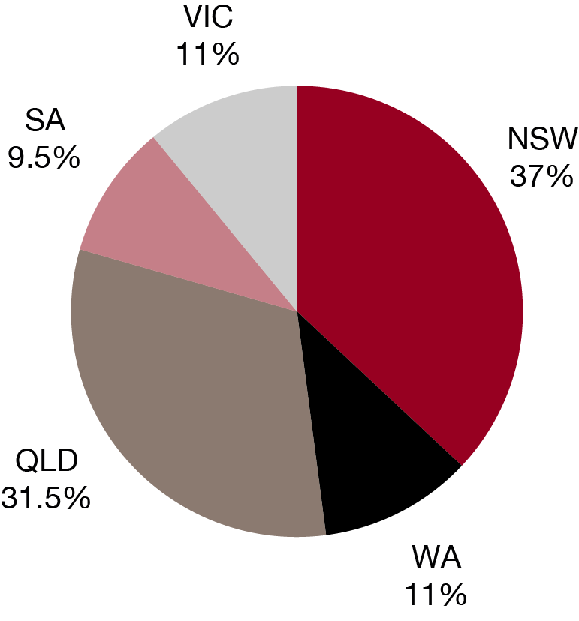

Graph 3.2: Distribution by state of withdrawals 2017–18

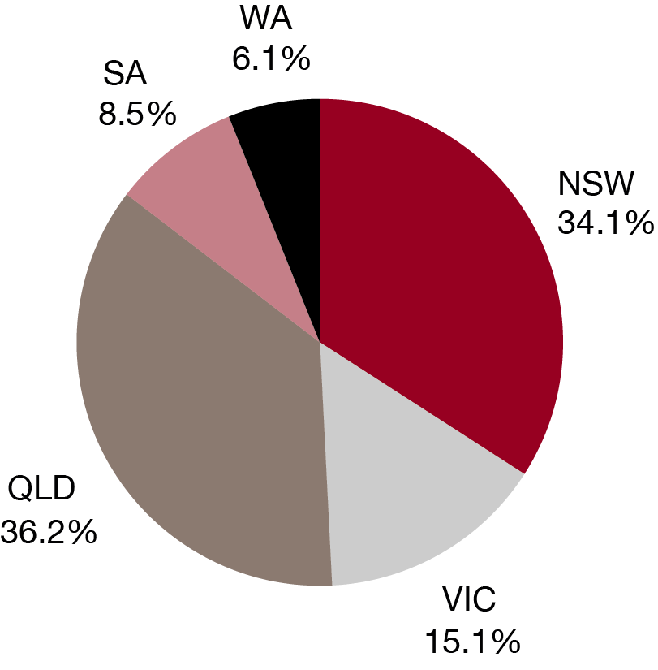

Graph 3.3: Withdrawals as a percentage of finalisations

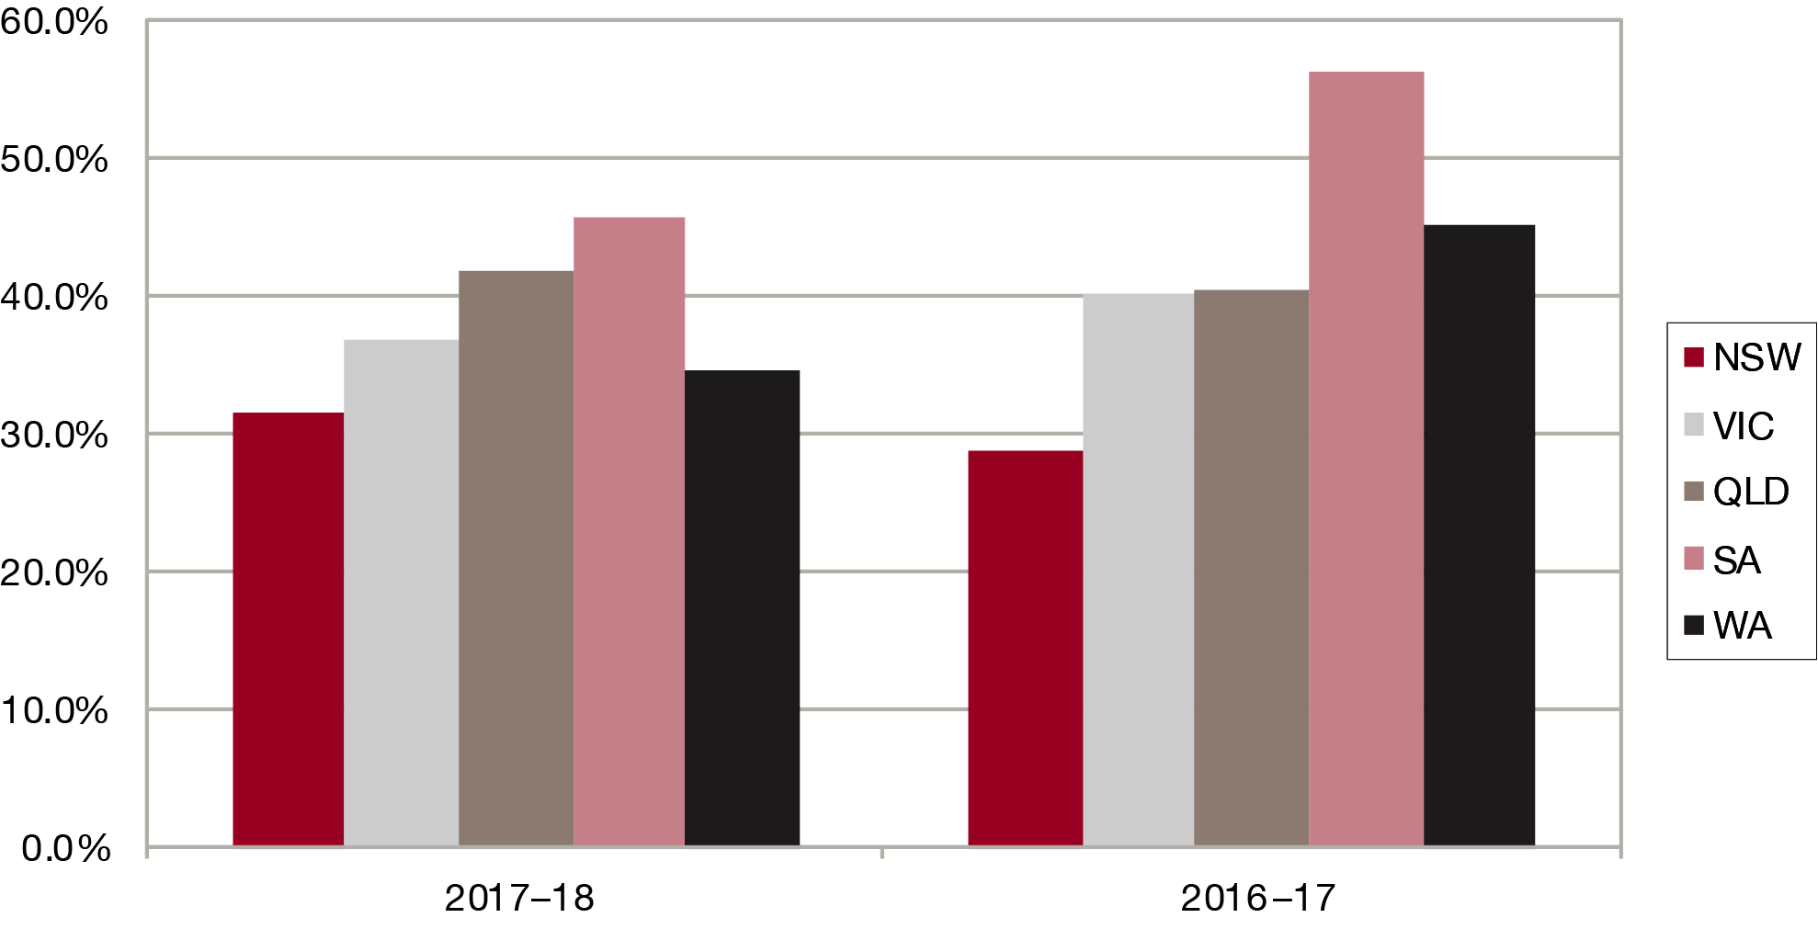

### OUTCOME 5: ACCESSIBLE AND RESPONSIVE TO VETERAN COMMUNITY STAKEHOLDERS

#### Representation for Applicants

Representation for applicants at VRB hearings is provided by a number of exservice and related organisations and by some private individuals.

| Table 9: Representation at hearings | | | | | | | |
| --- | --- | --- | --- | --- | --- | --- | --- |
|  | Year | NSW | VIC | QLD | SA | WA | AUST |
| In absentia | 2017–18 | 15 | 10 | 26 | 5 | 6 | 62 |
|  |  | 5.5% | 5.6% | 5.7% | 5.2% | 5.8% | 5.6% |
|  | 2016–17 | 12 | 13 | 31 | 4 | 8 | 68 |
|  |  | 3.6% | 4% | 6.7% | 4.3% | 6.1% | 5.1% |
| Represented | 2017–18 | 222 | 144 | 365 | 78 | 83 | 890 |
|  |  | 80.7% | 81.4% | 80.2% | 80.4% | 79.8% | 80.3% |
|  | 2016–17 | 295 | 287 | 385 | 74 | 111 | 1152 |
|  |  | 89.4% | 89.4% | 83.3% | 78.7% | 84.1% | 86% |
| Unrepresented | 2017–18 | 38 | 23 | 64 | 14 | 15 | 156 |
|  |  | 13.8% | 13% | 14.1% | 14.4% | 14.4% | 14.1% |
|  | 2016–17 | 24 | 21 | 45 | 16 | 13 | 119 |
|  |  | 7.3% | 6.5% | 9.7% | 17% | 9.8% | 8.9% |
| Total heard | 2017–18 | 275 | 177 | 455 | 97 | 104 | 1108 |
|  | 2016–17 | 330 | 321 | 462 | 94 | 132 | 1339 |

The great majority of all applicants (80.3 per cent) are represented at hearings in some way. A small proportion (5.6 per cent) of applicants who have ‘in absentia’ hearings are represented, but both the applicant and the representative have chosen not to participate at the hearing. The representatives in those cases sometimes provide written submissions to the VRB.

Graph 4.1: Representation at all hearings

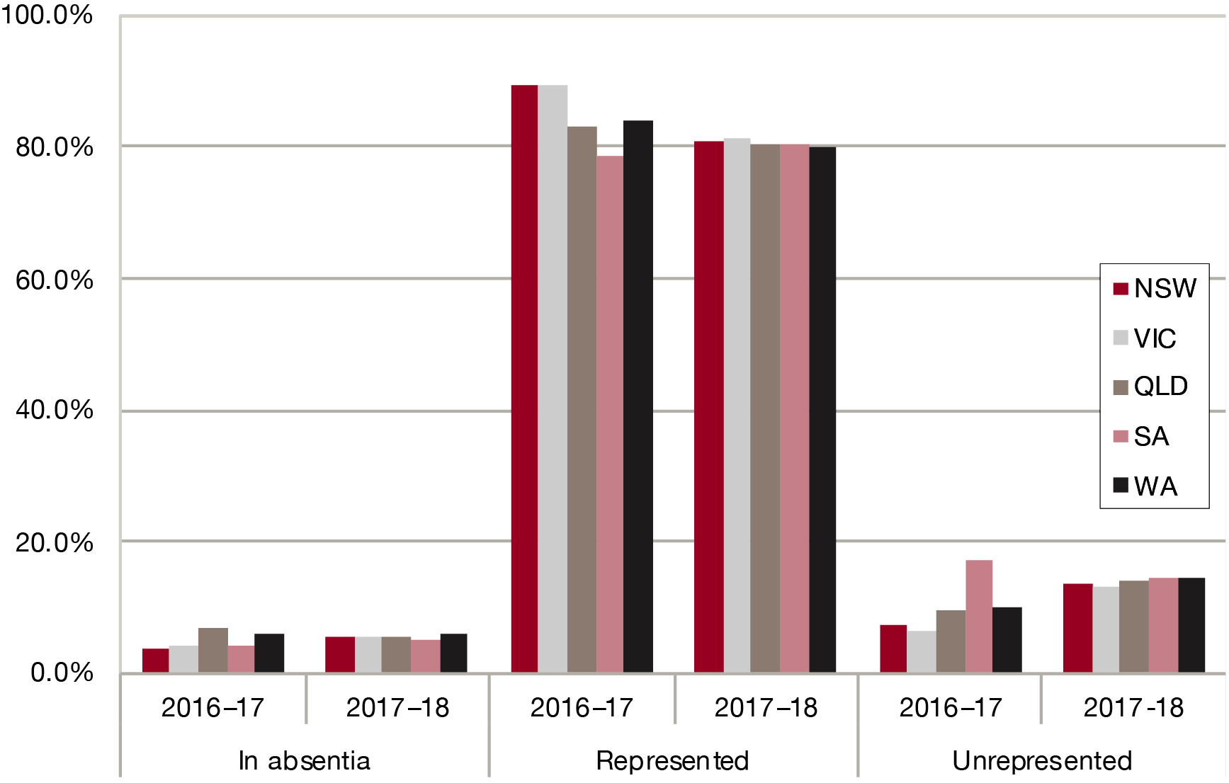

Graph 4.2: Representation at hearings nationally 2017–18

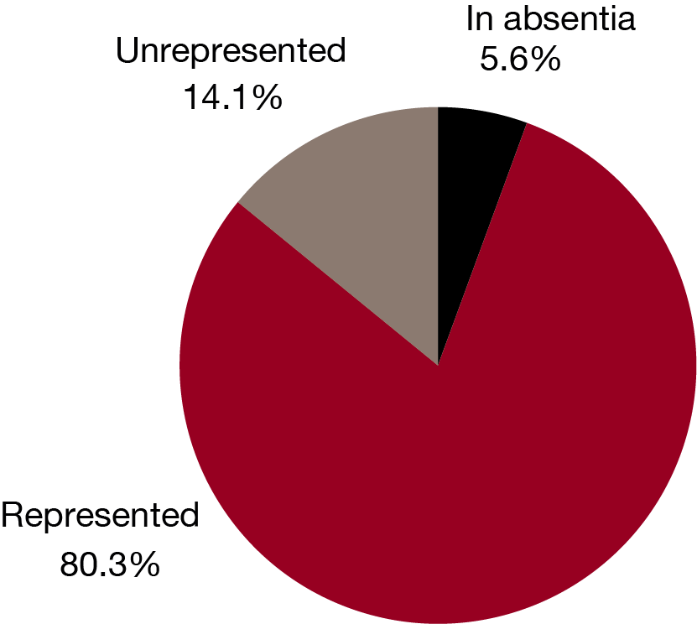

There are several ways that applicants and their representative can participate at hearings: one or both can have a telephone hearing, or one or both can appear in person. Combinations of applicant and representative participation are also possible. In addition, in 2000-01, the VRB undertook a trial of video hearings to enhance its service to applicants in regional areas. The number of video hearings has varied but has become a popular method of hearing cases with some representatives in Queensland. The provision of video hearings is a useful additional means of providing hearings on a timely basis for applicants in regional areas. The VRB remains committed to conducting regional hearings while there are sufficient cases available in those areas. However, video conferencing enables some applications to be heard sooner as the VRB does not have to wait for other applications in that region to be ready for hearing.

### Regional Hearings

During 2017–18 regional hearings were arranged in the Gold Coast, Canberra, Hobart and Launceston. Table 11 and Graph 5.3 show the number of days of hearings, and applications heard in the above locations.

|  |  |  |  |
| --- | --- | --- | --- |
| Table 10: Regional hearings | | | |
|  | **Year** | **Days** | **Applications** |
| Gold Coast | 2017–18 | 3 | 7 |
|  | 2016–17 | 19 | 53 |
| Canberra | 2017–18 | 13 | 36 |
|  | 2016–17 | 11 | 23 |
| Tasmania | 2017–18 | 14 | 36 |
|  | 2016–17 | 12 | 35 |
| Total | 2017–18 | 30 | 79 |
|  | 2016–17 | 42 | 111 |

Graph 4.3: Regional hearings

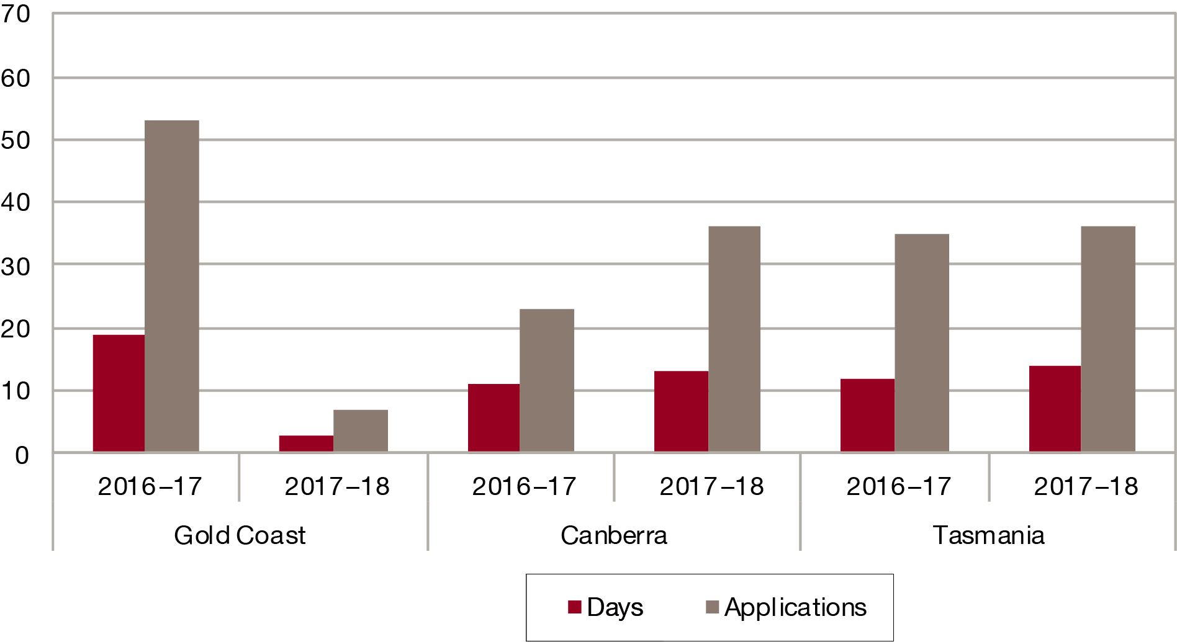

### Representation at VRB Hearings by the Repatriation Commission, MRCC, and Service Chiefs

The Repatriation Commission and the MRCC are formally parties to all proceedings before the VRB for matters arising under the VEA and MRCA respectively. Additionally, the service chiefs may choose to be a party in applications concerning the MRCA. As a matter of practice, however, they have seldom been represented at VRB hearings. During 2016–17 neither of the Commissions nor a service chief was represented in any VRB hearings.

### Service Charter

The VRB’s service charter sets out our commitment of service to our clients. It is a public statement regarding the type and quality of services that the veteran community can expect to receive from the VRB.

The VRB is committed to maintaining and improving the quality of its services. We monitor our performance in meeting the commitments set out the Charter. A copy of the charter can be viewed on the VRB’s website (www.vrb.gov.au).

### Compliments and Complaints

In the 2017–18 year, the VRB received 20 compliments and 26 complaints.

The 26 complaints referred involved the following issues: concern about the conduct of a VRB hearing, the decision or aspects of a decision (11); ADR processes (nine); handling of VRB applications (three); information obtained via DVA (two); privacy breech (one).

Each of these concerns was examined in detail and responses were provided in a timely manner. The VRB is pleased that the complaints are few relative to the total of matters dealt with. However, the issues raised were significant to the individuals concerned. The VRB continues to aim at improving its client service to reduce the possibility of future complaints.

### Other Activities

The VRB worked closely during the year with ex-service and related organisations and the parties to its hearings with a view to ensuring that its procedures worked effectively. Senior VRB staff participated in various workshops and seminars conducted by ex-service organisations and the Department. The VRB took steps to significantly improve the accessibility and quality of information that is provided to parties. Notably, additional information on the VRB website including an updated General Practice Direction (to reflect the new procedures in place following the 2014 legislative amendments), a dedicated ADR page of the website with templates and guidelines, VRB Case Notes and other general updated guidelines such as video hearings and factsheets. The Board also continued to conduct advocates liaison meetings, across Australia, to further enhance communication with the ex-service community.

The Principal Member, certain other members and senior staff attended a number of administrative law conferences and contributed to training programs managed by ex-service organisations for the training of pension and welfare officers and representatives. The Principal Member and National Registrar attended and addressed a number of state and national ex-service organisation meetings and maintained close contact with the larger advocacy organisations within the veteran community.

### Practice Directions

The Board’s General Practice Direction, Adjournment Practice Direction and Alternative Dispute Resolution Guidelines were updated this year to reflect the 2014 legislative amendments and continue to remain in place. The aim of the GPD is that the Board, wherever possible, will finalise applications for review within 12 months of lodgement. However, the practice direction recognises that the particular steps to be taken in finalising each application will vary and that the Board will determine in consultation with applicants and their representatives what should be done to achieve finalisation in an effective and efficient manner. The practice direction provides guidance on:

* the trial of ADR (and ADR available in non-trial locations)
* responsibilities of representatives
* section 137 documents
* obtaining further evidence
* lodging submissions, further evidence and certificates of readiness
* case appraisal and other forms of alternative dispute resolution
* adjournments

A copy of the GPD and other practice directions can be viewed on the VRB’s website (www.vrb.gov.au).

### Regular Advocates Liaison Meetings

This year the Board continued to host regular advocate liaison forums in all locations across Australia to provide an opportunity for information exchange. While the format of the forums varies slightly in each location, they provide a welcome opportunity for the VRB to explain any changes to procedure, such as the General Practice Direction. This year the forums focused on the new ADR trial and a number of presentations were delivered on the steps and procedural changes. Dedicated forums were also hosted to allow advocates an opportunity to provide feedback on the trial and discuss issues with their peers. The VRB also receives very valuable feedback on areas where we are performing well, and areas where we need to improve. Following each forum action item, lists are compiled and the Board reports back to user groups at follow up forums.

### Improved information about the VRB

During the reporting year the VRB took steps to improve the quality of information that is provided. This included maintaining a comprehensive Internet site (www.vrb.gov.au) with detailed information and publications for applicants and their representatives, including Practice Notes, material and links concerning jurisdiction and procedures, relevant legislation, case law, and guidance for advocates and representatives.

The VRB also publishes:

* submission templates for advocates
* Practice Notes for members, staff and ESO representatives, which is published at http://www.vrb.gov.au/publications.html
* VRB Case Notes which are published at http://www.vrb.gov.au/publications.html
* an information brochure, which is sent to all applicants prior to their hearing
* an Operations Manual, which sets out details of the administrative processing of applications to the VRB, which is currently under review.

The VRB also continued to publish a journal called VeRBosity. This journal includes information about Statements of Principles, legislative amendments, and decisions by the Administrative Appeals Tribunal and courts in the veterans’ and military compensation field together with other items of interest. It is distributed on request to people involved in the jurisdiction and is available online at http://www.vrb.gov.au/publications.html

In order to optimise the quality of VRB decisions, it is important that members, applicants and advocates have access to appropriate library resources to enable research on material not contained in sources such as VeRBosity. Some library and source material is maintained in each registry with the larger concentrations in Sydney, Melbourne and Brisbane. These materials can be provided overnight between registries.

The VRB’s intermediate role and high-volume jurisdiction mean that members have to deal with their caseload as expeditiously as possible. At the same time, both parties expect the VRB to consistently reach the correct decision in accordance with the facts and relevant law. In order to accommodate these competing requirements, legal officers at the VRB provide members with research on particular problems that arise from time to time, to speedily provide them with:

* the relevant law as interpreted by the courts and the Administrative Appeals Tribunal
* legislative amendments
* relevant research papers
* details of significant or interesting VRB decisions.

An internal discourse bulletin and a comprehensive Collaborative Tools intranet site assists in providing members with this material. Members have also been provided with various handbooks and a ‘Quick Guide’ for easy reference use at hearing.

### Access and equity

In conjunction with the Department of Veterans’ Affairs strategy to comply with the Government’s social justice policy, the VRB observes the requirements of access, equity, .equality and participation.

The VRB serves an identifiable segment of the community. The VRB is aware of its obligations in dealing with elderly persons, people with non-English speaking backgrounds and persons with disabilities. The VRB holds hearings and video hearings in some regional areas to ensure easier access for applicants. All applicants are advised of their right of appeal to the AAT on receiving advice of a VRB decision. Senior VRB staff speak on a regular basis at pensions seminars run by exservice organisations and DVA, and visit regional areas to discuss the VRB’s operations with ex-service organisation representatives.

In recognition of the fact that its staff are made available by DVA and operate in a comparable environment, the VRB acts consistently with Departmental policies and initiatives in such matters as work health and safety, enterprise bargaining, industrial democracy and equal employment opportunity.

### Other Tribunals

The VRB maintains relationships with other tribunals through the following fora:

* Council of Australasian Tribunals (COAT),
* Commonwealth Heads of Tribunals (CHOTS),
* Meetings involving the senior managers/registrars from the above federal review tribunals
* General liaison between staff of specific corporate functions (including human resources, finance, training and information technology).

### Quality assurance

In order to gauge applicant satisfaction and further develop members, in 2017–18 the VRB:

* conducted a variety of face to face member training, including induction training and follow up GARP and MRCA training
* conducted Advocate Liaison meetings

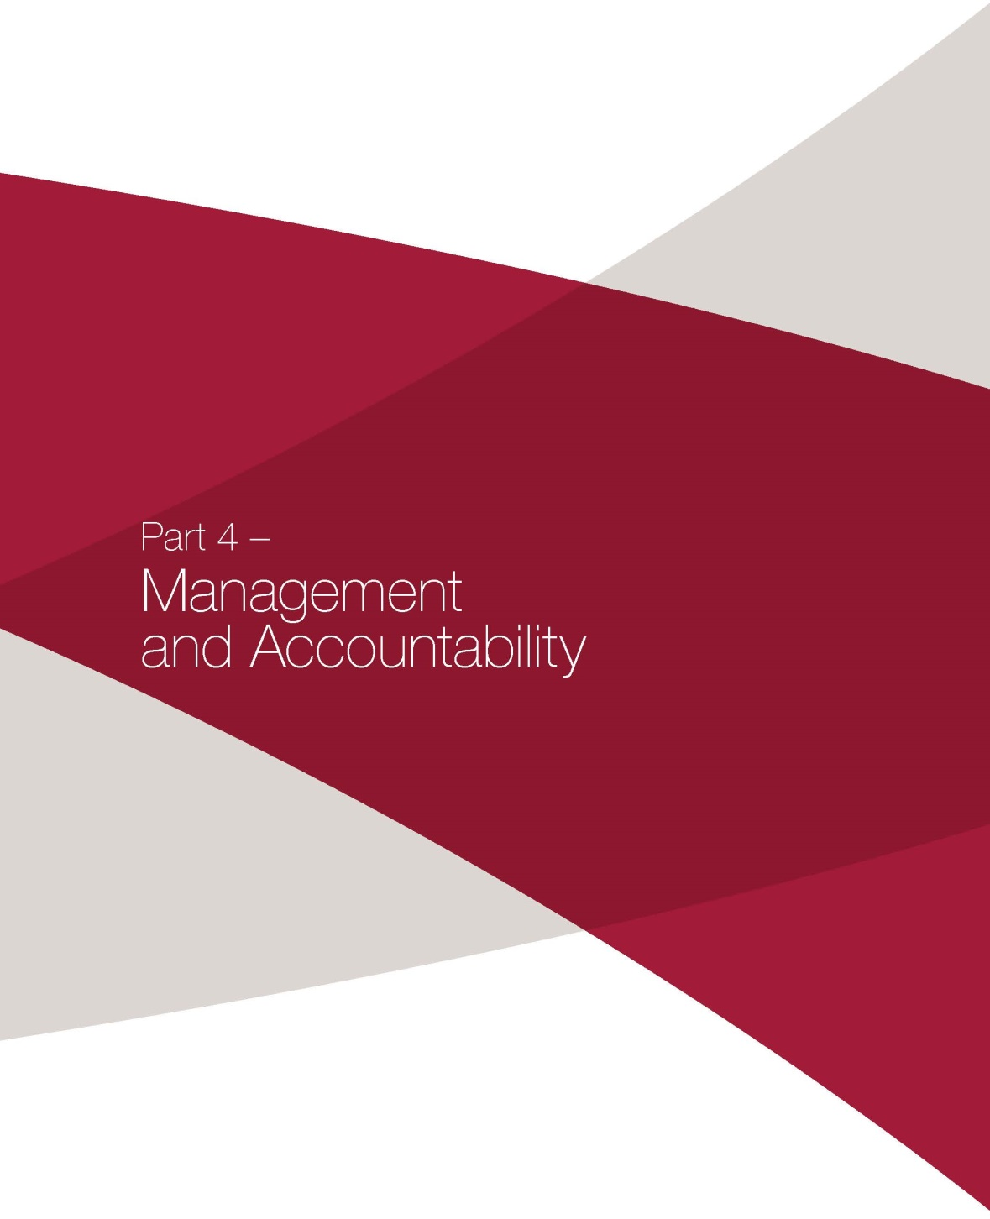

# Part 4 – Management and Accountability

### Staff

Under section 172 of the VEA, the Secretary of DVA is required to make available any staff required to assist the VRB in the performance of its statutory functions, who are employed under the terms of the *Public Service Act 1999* and the *DVA Enterprise Agreement 2012-2014*.

Comprehensive information on the *Enterprise Agreement 2015-2018* is available in DVA’s annual report. As at 30 June 2018, VRB employees were covered by this Australian Workplace Agreement. Performance pay is also no longer available to VRB employees.

On 30 June 2018 the VRB employed 28.5 full-time equivalent staff (including 4 contractors), compared to 25.9 staff as at 30 June 2017.

The break-up of staff at 30 June 2018 is set out in Tables 12 and 13, and in Graphs 6.1 to 6.3. Because the National Registry is situated in Sydney, its staff are shown together with those of the NSW State Registry under NSW.

|  |  |  |  |  |  |  |
| --- | --- | --- | --- | --- | --- | --- |
| Table 11: Staff | | | | | | |
|  | **Gender** | **NSW** | **VIC** | **QLD** | **SA** | **AUST** |
| EL 2 | Male |  | 0 | 0 | 0 |  |
|  | Female | 1 | 0 | 0 | 0 | 1 |
|  | Total | 1 | 0 | 0 | 0 | 1 |
| EL 1 | Male | 3 | 0 | 0 | 0 | 4 |
|  | Female | 1.4 | 0 | 1 | 1 | 2.4 |
|  | Total | 4.4 | 0 | 1 | 1 | 6.4 |
| APS 6 | Male | 1 | 0 | 0 | 0 | 1 |
|  | Female | 1 | 0 | 1 | 0 | 2 |
|  | Total | 2 | 0 | 1 | 0 | 3 |
| APS 5 | Male | 1 | 0 | 0 | 0 | 1 |
|  | Female | 1.9 | 0 | 0 | 0 | 1.9 |
|  | Total | 2.9 | 0 | 0 | 0 | 2.9 |
| APS 4 | Male | 2 | 0 | 0 | 0 | 2 |
|  | Female | 6 | 0 | 6.2 | 0 | 12.2 |
|  | Total | 8 | 0 | 6.2 | 0 | 14.2 |
| All staff | Male | 8 | 0 | 0 | 0 | 8 |
|  | Female | 11.3 | 0 | 8.2 | 1 | 20.5 |
|  | Total | 19.3 | 0 | 8.2 | 1 | 28.5 |

|  |  |  |  |  |  |  |
| --- | --- | --- | --- | --- | --- | --- |
| Table 12: Staff full-time and part-time | | | | | | |
|  | **Gender** | **NSW** | **VIC** | **QLD** | **SA** | **AUST** |
| Full-time | Male | 8 | 0 | 0 | 0 | 8 |
|  | Female | 10 | 0 | 6 | 1 | 17 |
|  | Total | 18 | 0 | 6 | 1 | 25 |
| Part-time | Male | 0 | 0 | 0 | 0 | 0 |
|  | Female | 1.3 | 0 | 2.2 | 0 | 3.5 |
|  | Total | 1.3 | 0 | 2.2 | 0 | 3.5 |
| Total all staff | Male | 8 | 0 | 0 | 0 | 8 |
|  | Female | 11.3 | 0 | 8.2 | 1 | 20.5 |
|  | Total | 19.3 | 0 | 8.2 | 1 | 28.5 |

Graph 5.1: Distribution of staff by state, 30 June 2018

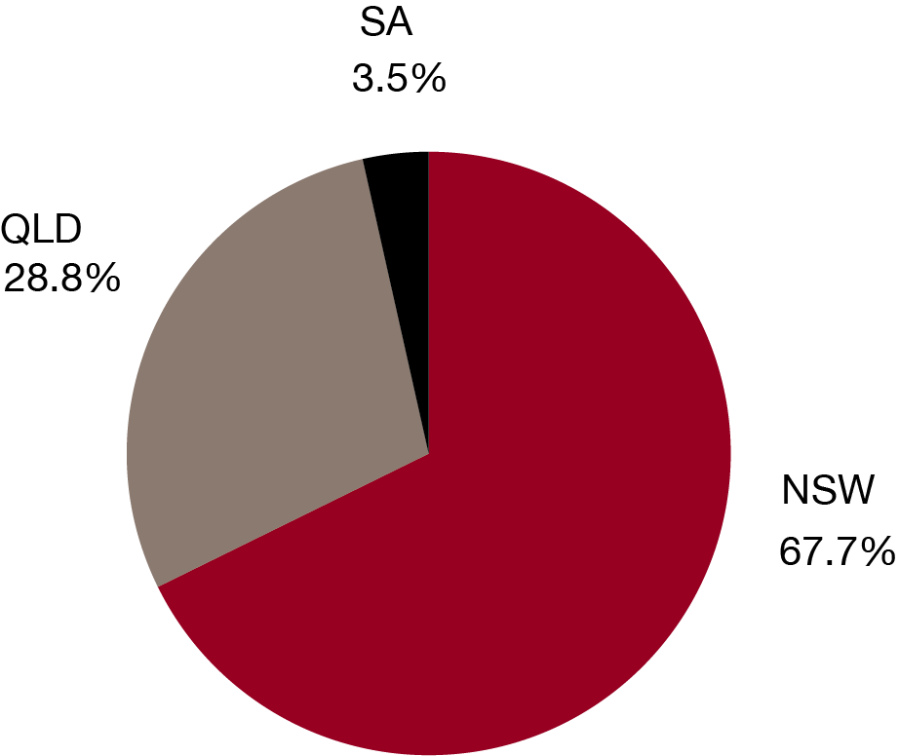

Graph 5.2: Distribution of staff by classification, 30 June 2018

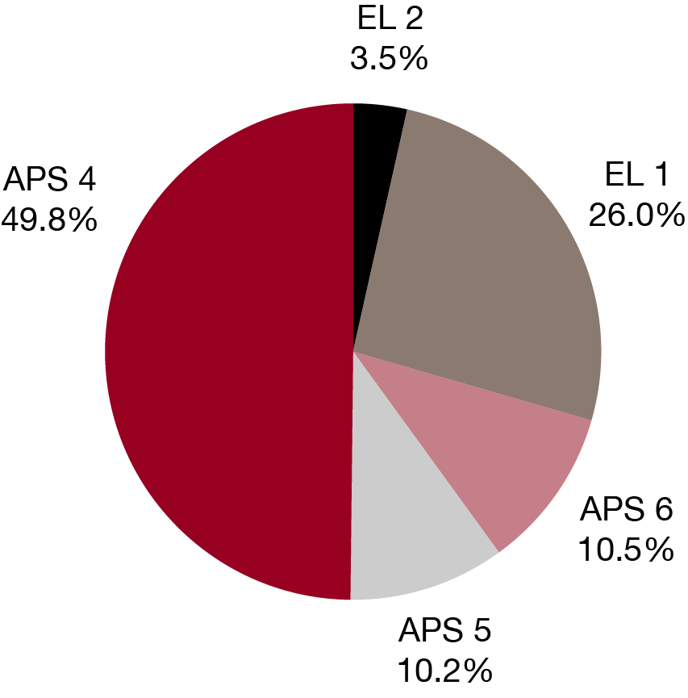

Graph 5.3: Distribution of staff by gender, 30 June 2018

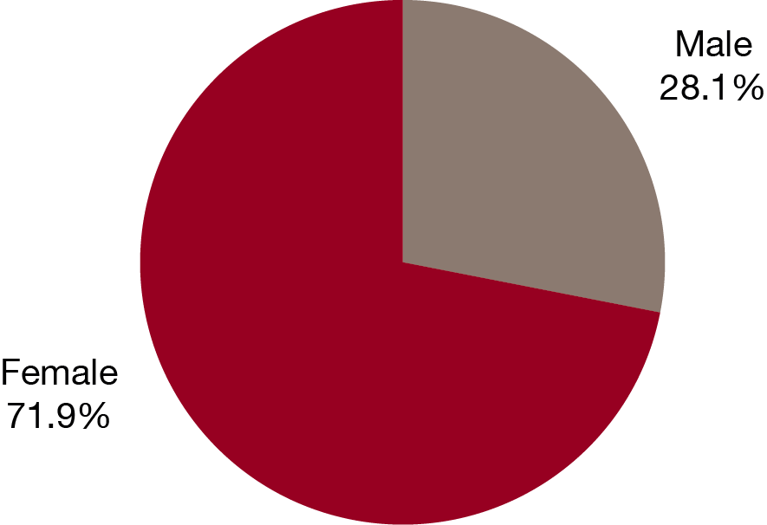

### Members

At 30 June 2018 there were 34 members of the VRB: the Principal Member, 11 Senior Members, 13 Services Members and 9 Members. Of these, the Principal Member was the only full-time appointee, all others were part-time. The number of women holding appointments was 14.

The break-up of membership at the end of the financial year is set out in Table 14 and Charts 5.4 to 5.6. Further details of the VRB membership are provided in Appendices 3 and 4.

|  |  |  |  |  |  |  |  |  |  |
| --- | --- | --- | --- | --- | --- | --- | --- | --- | --- |
| Table 13: Members | | | | | | | | | |
|  | **Gender** | **ACT** | **NSW** | **VIC** | **QLD** | **SA** | **WA** | **TAS** | **AUST** |
| Principal Member | Female |  | 1 |  |  |  |  |  | 1 |
| Senior Members | Male |  | 1 | 2 |  |  | 1 |  | 4 |
|  | Female | 1 | 4 |  | 2 |  |  |  | 7 |
|  | Total | 1 | 5 | 2 | 2 |  | 1 |  | 11 |
| Services Members | Male | 1 | 4 | 1 | 5 |  |  |  | 11 |
|  | Female |  | 1 |  |  |  | 1 |  | 2 |
|  | Total | 1 | 5 | 1 | 5 |  | 1 |  | 13 |
| Members | Male |  | 3 |  | 1 |  | 1 |  | 5 |
|  | Female | 1 |  | 2 |  |  |  | 1 | 4 |
|  | Total | 1 | 3 | 2 | 1 |  | 1 | 1 | 9 |
| All members | Male | 1 | 8 | 3 | 5 |  | 2 |  | 19 |
|  | Female | 2 | 6 | 2 | 2 |  | 1 | 1 | 14 |
|  | Total | 3 | 14 | 5 | 8 |  | 3 | 1 | 34 |

Graph 5.4: Distribution of members by state, 30 June 2018

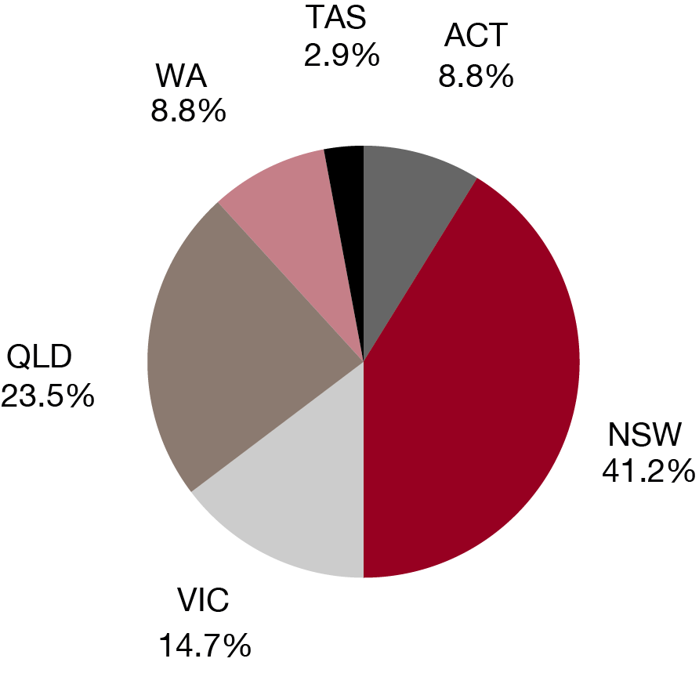

Graph 5.5: Distribution of members by type, 30 June 2018

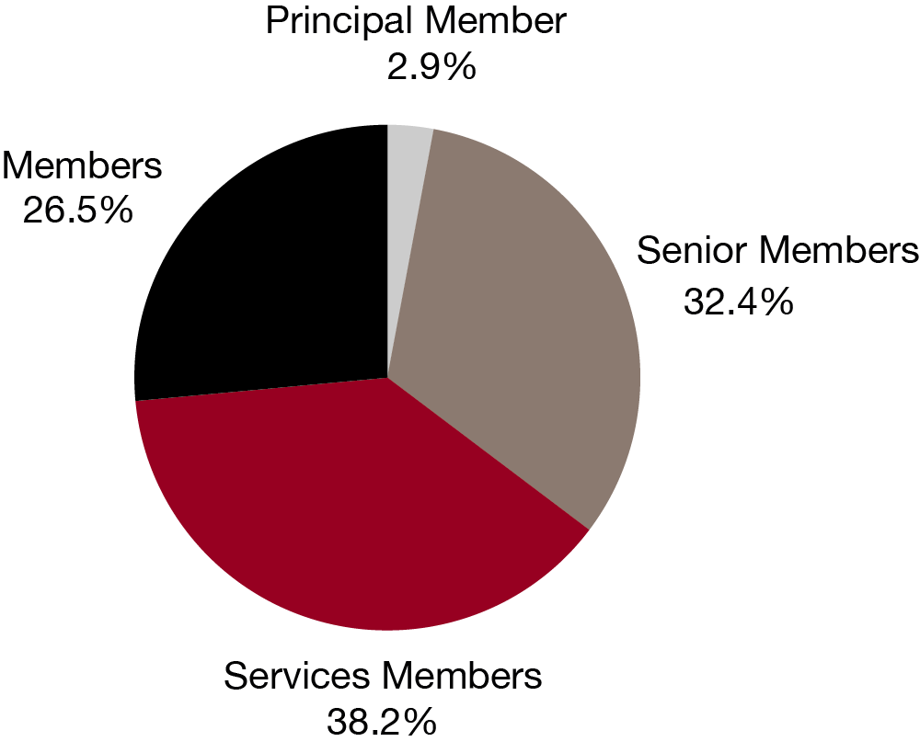

Graph 5.6: Distribution of members by gender, 30 June 2018

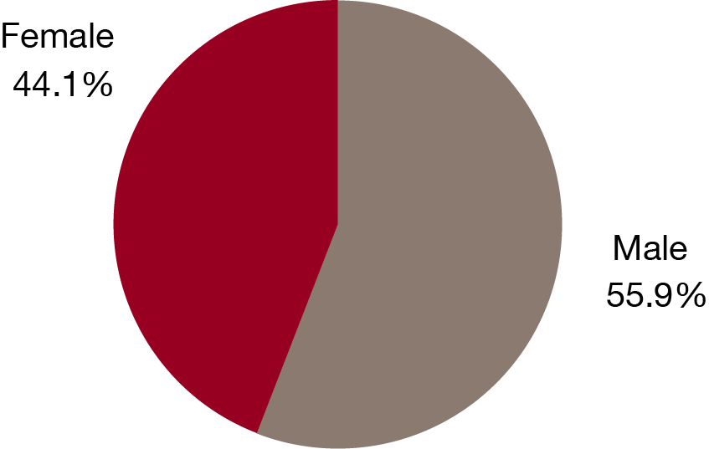

### Ethical standards

The VRB is committed to maintaining the highest ethical standards. Its core values are embedded in its Service Charter and underpin its operations.

The VRB is committed to maintaining a culture of trust and integrity among our senior staff and in our decision-making processes. VRB staff attend leadership and development programs facilitated by DVA, and all provide segments or modules focusing on ethics and integrity, including ethical decision making.

In terms of VRB Members, they are required to act in accordance with the Administrative Review Council’s Standards of Conduct for Tribunal Members, the Australian Public Service (APS) Values, the APS Code of Conduct and the Board’s Service Charter.

### Australian Public Service Values and Code of Conduct

All VRB staff are bound by the Australian Public Service Values and Code of Conduct. All staff are encouraged to incorporate these values into their own workplace ethic. References to the Australian Public Service Values and Code of Conduct are also incorporated into core staff training.

### Professional Standards for Tribunal Members

In addition to comprehensive guidance given to members in the VRB’s Members Handbook, members are guided by the Administrative Review Council’s publication, *A Guide to Standards of Conduct for Tribunal Members*. This document establishes principles of conduct relating to fairness, integrity, accountability and transparency, among others. The Guide is brought to the attention of all VRB members during induction activities and the principles referred to in ongoing member training. It also forms part of the members competency framework; against which members are appraised twice yearly. To ensure that ethical standards are upheld, members, as statutory office holders, are required to complete a private interests declaration form.

### Ecologically Sustainable Development and Environmental Performance

The VRB remains committed to minimising the impact of its workplaces on the environment and promoting environmentally supportive work practices. The VRB continues to increase purchases of ‘green’ energy, recycle waste paper and materials and to implement measures to reduce the amount of energy and resources used. The VRB also ensures it is compliant with relevant environment regulations and that suppliers are aware of our environmental commitments and arrangements. The VRB will continue to improve its awareness of environmental issues and promote awareness in its business practices in all its registries.

DVA monitors and reports on energy consumption in the buildings occupied by the VRB, and information regarding this is included in Annual Report of the DVA.

### Senior Management

Ms Jane Anderson is the Principal Member of the Board. She has been appointed for a five year term commencing on 31 January 2018. The Principal Member is appointed by the Governor-General and is responsible for the national management of the VRB.

Senior Members of the Board provide leadership and support for Members and Services Members, by way of mentoring and training, as well as informally. Up until 30 June 2018, the Senior Members were June McPhie, Les Young, Hilary Kramer, Jenny D’Arcy, Jillian Moir, Christopher Wray, Robert Douglass, Alison Colvin, Tammy Williams and Gary Barrow.

The National Registrar directs the operations of the VRB at a national level and coordinates the activities of the state registries. The State Registrars are responsible for the administration and operation of their respective registries. All State Registrars report to the National Registrar.

### Risk Management

The Risk Management Framework ensures that all identified risks relevant to the VRB are considered and that a systematic approach to risk mitigation is followed. The approach adopted by the VRB is consistent with the Australian Risk Management Standard (AS/NZS 4360) and considers the following risk areas:

* maintaining a safe work environment for staff, members, clients and visitors
* safeguarding and maintaining assets
* managing human resources
* managing technology and information resources
* ensuring compliance with environmental obligations
* achieving established objectives and goal
* ensuring the reliability and integrity of financial and operational information
* complying with internal policies and procedures
* complying with laws and regulations
* managing change in the VRB’s internal and external environments
* managing ‘significant interruption’ to critical business processes.

For each of these areas, the likelihood and consequences of identified risks have been determined

and inform the VRB’s approach to risk mitigation.

### Asset Management

All the assets of the VRB are provided to it by DVA. As such, the Department manages, conducts regular stocktakes, and accounts for those assets.

### Professional Development and Performance

Member Professional Development is based on the framework of competencies developed for the VRB. The VRB’s appraisal scheme combines a mid-year self-assessment with appraisal by another VRB member and then a final year assessment with another VRB member or the Principal Member against the framework of Member competencies.

A range of learning activities was offered to members during 2016–17, including participating in external seminars, workshops and other professional development activities such as the COAT conferences to stay up to date with developments relevant to their work.

Training innovations were also introduced to benefit the wider membership. These focused on rolling out a number of e-learning programs focused on aspects of MRCA and refresher training on common legal issues.

There have also been many initiatives undertaken during the reporting year aimed at maintaining and enhancing the skills of staff. These include:

* participation in regular State Registrar and Conference Registrar meetings
* regular registry staff meetings
* attendance of members and staff at relevant external conferences, including the Council of Australasian Tribunals national and state based conferences , Australian Institute of Judicial Administration’s Tribunals’ Conference and the annual conference of the Australian Institute of Administrative Law
* participation of members and staff in relevant external training courses run by DVA and the Australian Public Service Commission and others.

The VRB remains actively involved in the joint Tribunals Learning Development Committee and the Council of Australasian Tribunals as part of its ongoing commitment to professional development.

### Work Health and Safety, National Disability Strategy and Social Inclusion

As mentioned above, the VRB is within the Veterans’ Affairs portfolio and although it is an independent body from DVA, it follows Departmental guidelines concerning work health and safety, as well as access and equity issues.

The VRB is included within the Department’s health and safety arrangements, which provide a flexible framework for proactively managing work health and safety. Information relating to Part 4 Clause 4 of the *Work Health and Safety Act 2011* (Cth) (WHS Act) is contained in *Appendix H Workplace Health and Safety* of the Department’s annual report.

The VRB is also included within the Department’s *Workplace Diversity Policy and Action Plan 2016-20*. The VRB is also covered by the Department’s systems and processes to provide workplace support for employees with a disability. More information on both of these issues can be found in the Department’s annual report.

### Resources

In the Veterans’ Affairs Portfolio Budget Statement (PBS) and the Portfolio Additional Estimates Statement (PAES) the VRB comes under Outcome 1 and Program 1.3. Detailed financial statements including those relating to the VRB are contained in the DVA Annual Report.

Table 15 outlines actual expenditure for the VRB for the 2016–17 and 2017–18 financial years. Total expenditure for the VRB in the financial year 2016–17 was $5 565 389 compared to $6 038 583 in 2017–18.

### New Consultancy Services Contracts

During the 2017–18 financial year the VRB did not commission any new consultancy services contract. More information on contracts and consultancies is available through the AusTender website.

|  |  |  |
| --- | --- | --- |
| Table 14: Veterans’ Review Board Expenditure | 2016–17 ($’000) | 2017–18 ($’000) |
| Salaries (includes superannuation) |  |  |
| Members | 2,069 | 2,541 |
| Staff (includes o/time & temps) | 2,887 | 2,903 |
| TOTAL | 4.957 | 5,444 |
| Fares |  |  |
| Members | 87 | 92 |
| Staff | 43 | 40 |
| Cars (includes parking) | 7 | 10 |
| TOTAL | 137 | 142 |
| Accommodation |  |  |
| Members | 88 | 95 |
| Staff | 32 | 37 |
| TOTAL | 120 | 132 |
| Travelling Allowance |  |  |
| Members | 55 | 65 |
| Staff | 17 | 20 |
| TOTAL | 72 | 75 |
| Office Requisites |  |  |
| Stationery and office requisites | 90 | 95 |
| Printing | 15 | 19 |
| TOTAL | 105 | 114 |
| Postage and Telephones |  |  |
| Postage | 46 | 49 |
| Telephones/fax/IT | 1 | 1 |
| TOTAL | 47 | 50 |
| Incidental Expenditure |  |  |
| Freight & cartage | 22 | 25 |
| Advertising | 0 | 0 |
| Training | 54 | 16 |
| Miscellaneous | 24 | 10 |
| Archiving | 27 | 30 |
| TOTAL | 130 | 81 |
| GRAND TOTAL | 5,565 | 6,038 |

### Fraud control

The VRB remains committed to developing and maintaining best practice strategies for the prevention and detection of fraud. The Finance Manager bears responsibility for fraud control and prevention and detection activities within the VRB.

There were no incidents of fraud detected or reported for the VRB during the financial year.

Certification of VRB
Fraud Control Arrangements

I, Jane Anderson, certify that I am satisfied that for the financial year 2017–18 the VRB:
• Has had appropriate fraud risk assessments and fraud control plans in place that comply with the Commonwealth Fraud Control Guidelines;
• Has had appropriate fraud prevention, detection, investigation and reporting procedures and processes in place; and
• Has collected and reported on annual fraud data in a manner that complies with the Commonwealth Fraud Control Guidelines.

Jane Anderson
Principal Member
28 September 2018


# Appendix 1

### Court Decisions

Under the VEA, the MRCA and the *Administrative Appeals Tribunal Act 1975*, decisions of the VRB are subject to review on the merits by the Administrative Appeals Tribunal (AAT). Parties may appeal to the Federal Court on questions of law from decisions of the AAT.

While there is no direct right of appeal to the Federal Court from a decision of the VRB, decisions are subject to review by the Federal Court under the *Administrative Decisions (Judicial Review) Act 1977* (AD(JR) Act), on the grounds set out in that Act or alternatively the *Judiciary Act 1903*.

Certain matters may be heard in the Federal Magistrates Court, either in its original jurisdiction under the AD(JR) Act or upon transfer from the Federal Court.

### Federal Court of Australia

### Administrative Appeals Tribunal Act 1975

In 2017–18 there were three Federal Court judgments where the VRB had been a part of the appeal path:

* *Saxton v Repatriation Commission* [2017] FCA 904 (7 August 2017)
* *Whitehouse v Repatriation Commission* [2017] FCA 1085 (15 September 2017)
* *Saltmarsh v Repatriation Commission* [2018] FCA 28 (29 January 2018)

### Issues dealt with by Court Decisions

In *Saxton*, the appeal to the Federal Court was concerned with the AAT’s construction of the applicant’s “last paid work” in subsections 24(2A)(d) and (g). The appeal was successful on the point that the AAT wrongly construed section 24(2A)(g) as requiring that both the applicant’s Navy work and civilian work must separately meet the criterion in section 24(2A)(g). The Court considered the purpose of section 24(2A)(g) is best promoted by construing “last paid work” as referring to any one of the remunerative activities found to constitute “last paid work” for the purposes of section 24(2A)(d).

Please note, there have been legislative changes to sections 23(3A)(g) and 24(2A)(g) of the VEA, which apply to claims or AFIs made on or after 1 July 2017. The *Veterans’ Affairs Legislation Amendment (Budget Measures) Act 2017* removes the distinction between a veteran who was working as an employee, or on his or her own account. It also removes the requirement that the veteran worked for the same employer, or in the same field of work.

In *Whitehouse*, the appeal to the Federal Court involved an application for intermediate rate of pension. The applicant unsuccessfully argued that his full-time work should be considered to be his “remunerative work (last paid work)” for the purpose of section 23(3A)(d) of the Act.

The Court indicated that what section 23(3A)(d) requires is the identification of the particular remunerative work which constituted the applicant’s “last paid work” *at the time* that he made his application for an increased pension rate and then consideration of whether he was prevented from continuing to undertake that work. On the facts found by the AAT, the applicant ceased to be engaged in full-time remunerative work in about June 2012 and at that time he had already turned 65. He then commenced working between four and five hours per day as a consultant solicitor in the same firm. In 2014 when he made his application for an intermediate rate of pension, he was continuing to perform this work as a part-time consultant solicitor. The Court indicated this was the “remunerative work” which he was *last* undertaking and for which he was *last paid* before he made the application. The applicant continued to perform this particular remunerative work during the whole of the assessment period. Therefore, at no time during that period was Mr Whitehouse prevented, by his war-caused disabilities, from continuing to undertake his last paid remunerative work as a part-time consultant solicitor.

In summary, as the applicant, who was over 65, had not stopped undertaking his last paid work he did not meet the criteria in section 23(3A)(d).

In *Saltmarsh*, the appeal to the Federal Court involved a disability pension claim for spondylolisthesis L5/S1. The appeal was successful on the point that the AAT failed to address the hypothesis advanced by the applicant concerning inability to obtain appropriate clinical management. Essentially, the AAT failed to correctly identify the hypothesis. Further, the Court considered the AAT failed to have regard to the whole of the material before it. Alternatively, the Court found the AAT engaged in impermissible fact-finding at stage 3 of the *Deledio* process.

While the Court noted the AAT’s reasons were not to be approached with an eye closely attuned to the detection of error, the Court could not accept the Commission’s submission that, on a fair reading of the reasons, the AAT addressed the hypothesis Mr Saltmarsh advanced. The AAT’s decision was set aside and remitted for hearing.

### VeRBosity

All Court decisions concerning veterans’ entitlements and relevant military rehabilitation and compensation matters are noted and summarised in the VRB’s publication, *VeRBosity*, which is usually published annually. Electronic versions are available at http://www.vrb.gov.au/publications.html.

### Practice notes

The VRB also publishes practice notes in relation to important court decisions, which can be found on the website at: http://www.vrb.gov.au/publications.html#_practice

# Appendix 2

### Other Forms of External Scrutiny

Decisions and actions of the VRB may be the subject of complaints to the Ombudsman. In addition, access to documents held by the VRB may be sought under the *Freedom of Information Act 1982*.

### Ombudsman

During 2017–18 the Ombudsman did not notify the VRB of any complaints.

### Freedom of Information Act 1982

There were seven requests to the VRB for access to documents under the *Freedom of Information Act 1982* during 2016–17.

### Privacy Commissioner

The VRB is subject to the *Privacy Act 1988*. The VRB continually assesses its compliance with the Information Privacy Principles, which determine the way the VRB deals with personal information.

### Australian Human Rights Commission

The VRB is subject to the jurisdiction of the Australian Human Rights Commission. The Commission did not notify the VRB of any complaints during 2017–18.

### Auditor-General

During 2017–18 the Auditor-General did not conduct any inquiries or make any reports in relation to the VRB.

### Reports by Parliamentary Committees

On 15 August 2017, the Senate Foreign Affairs, Defence and Trade References Committee handed down a report titled “The Constant Battle: Suicide by Veterans” following their inquiry regarding suicide by veterans and ex-service personnel.

Chapter 7 contained commentary regarding the VRB. Recommendation 24 called for the Australian Government to establish an independent review concerning the representation of veterans before the Veterans’ Review Board.

A link to the report can be found on the Parliament of Australia website at:

http://www.aph.gov.au/Parliamentary_Business/Committees/Senate/ Foreign_Affairs_Defence_and_Trade/VeteranSuicide/Report

# Appendix 3

| **Member** | **Office** | **First appointed** | **Current appointment expires** | **Gender** | **Location** |
| --- | --- | --- | --- | --- | --- |
| Ms Jane Anderson | Principal Member | 31 Jan 2018 | 31 Jan 2023 | F | NSW |
| Commander Gary Barrow | P/T Senior Member | 1 Oct 2007 | 30 Sep 2018 | M | WA |
| Ms Robyn Bailey | P/T Senior Member | 12 Nov 2015 | 11 Nov 2020 | F | NSW |
| Ms Alison Colvin | P/T Senior Member | 1 Jan 2011 | 30 Sep 2018 | F | QLD |
| Ms Jennifer D’Arcy | P/T Senior Member | 1 Jun 2001 | 30 Sep 2018 | F | NSW |
| Mr Robert Douglass | P/T Senior Member | 4 Aug 2014 | 11 Nov 2020 | M | VIC |
| Ms Hilary Kramer | P/T Senior Member | 30 Jul 1998 | 30 Sep 2018 | F | NSW |
| Ms June McPhie | P/T Senior Member | 12 Nov 2015 | 11 Nov 2020 | F | ACT |
| Ms Jillian Moir | P/T Senior Member | 1 Jan 2011 | 11 Nov 2020 | F | NSW |
| Ms Tammy Williams | P/T Senior Member | 12 Nov 2015 | 11 Nov 2020 | M | QLD |
| Mr Christopher Wray | P/T Senior Member | 1 Oct 2006 | 30 Sep 2018 | M | VIC |
| Colonel Leslie Young OAM (Retd) | P/T Senior Member | 1 Oct 1997 | 30 Sep 2018 | M | NSW |
| Brigadier Mark Bornholt (Retd) | P/T Services Member | 1 Jan 2011 | 11 Nov 2020 | M | ACT |
| Dr Scott Clark | P/T Services Member | 1 Jan 2011 | 11 Nov 2020 | M | QLD |
| Ms Nadine Crimston | P/T Services Member | 12 Nov 2015 | 11 Nov 2020 | M | NSW |
| Brigadier Christopher Hamilton | P/T Services Member | 7 Dec 2011 | 30 Sep 2018 | M | QLD |
| Commodore Simon Hart CSC RAN (Retd) | P/T Services Member | 1 Jan 2011 | 11 Nov 2020 | M | NSW |
| Ms Louise Hunt | P/T Services Member | 12 Nov 2015 | 11 Nov 2020 | F | NSW |
| Colonel Peter Maher | P/T Services Member | 1 Mar 2013 | 11 Nov 2020 | M | QLD |
| Colonel Robin Regan CSC (Retd) | P/T Services Member | 28 May 1999 | 30 Sep 2018 | M | VIC |
| Mr Francis Roberts | P/T Services Member | 12 Nov 2015 | 11 Nov 2020 | M | QLD |
| Commander Iain Whitehouse (Retd) | P/T Services Member | 7 Dec 2011 | 30 Sep 2018 | M | QLD |
| Air Commodore Bruce Wood (Retd) | P/T Services Member | 1 Oct 2006 | 30 Sep 2018 | M | NSW |
| Colonel Warwick Young | P/T Services Member | 31 Mar 2008 | 30 Sep 2018 | M | NSW |
| Colonel Christopher Austin | P/T Member | 12 Nov 2015 | 11 Nov 2020 | M | QLD |
| Ms Sharon Brennan | P/T Member | 12 Nov 2015 | 11 Nov 2020 | F | VIC |
| Mr Frank Brown | P/T Member | 1 Jun 2001 | 30 Sep 2018 | M | NSW |
| Ms Linda Corbould | P/T Member | 12 Nov 2015 | 11 Nov 2020 | F | TAS |
| Lieutenant Colonel Geoff Hourn | P/T Member | 1 Jan 2011 | 30 Sep 2018 | M | WA |
| Mr Christopher Keher | P/T Member | 31 Mar 2008 | 11 Nov 2020 | M | NSW |
| Ms Sandra Kerr | P/T Member | 12 Nov 2015 | 11 Nov 2020 | F | VIC |
| Ms Josephine Lumb | P/T Member | 12 Nov 2015 | 11 Nov 2020 | F | ACT |
| Mr Neville Wyatt | P/T Member | 12 Nov 2015 | 11 Nov 2020 | M | NSW |

# Appendix 4

### Membership of the Veterans’ Review Board – Biographies

Ms Jane Anderson  
Principal Member, NSW

Ms Anderson has been appointed as the Principal Member of the Veterans’ Review Board for a five year term commencing on 31 January 2018. Previously she had been appointed as a Member of the VRB in 2015. She holds a Bachelor of Laws (with Honours) degree from Flinders University of South Australia and a Master of Law degree from Cambridge University, United Kingdom. After working as a Senior Legal Officer for the Commonwealth Director of Public Prosecutions she was appointed as a Deputy President of the Guardianship Board of South Australia in 2009. She served in this role for five years before being appointed as a Senior Legal Member of the NSW Civil and Administrative Tribunal in 2014.

Colonel Christopher Austin  
Member, QLD

Colonel Austin has served as an Army Officer since 1980. His service has included operational service in East Timor, the Middle East and the Queensland floods. He is an active member of the Army Reserve and is a self-employed Management Consultant and Company Director.

Ms Robyn Bailey  
Senior Member, NSW

Ms Bailey holds Bachelor of Laws and Arts as well as a Master of Laws degree from the University of New South Wales. After working in private practice she was appointed as a Member of the Guardianship Tribunal in 2007 and to the Consumer Trader and Tenancy Tribunal in 2009. She is currently employed as a Senior Member of the NSW Civil and Administrative Tribunal and also works as a Mediator in the District Court of NSW, the Workers Compensation Commission and for her own company. She is also facilitator for the Defence Abuse Response Taskforce.

Commander Gary Barrow  
Senior Member, WA

Commander Barrow served as a permanent officer in the Royal Australian Navy for 26 years. In 1983 he graduated from the University of Sydney Law School, and also qualified as a Legal Officer in the Royal Australian Navy. He has been in private practice as a solicitor since 1986 and has continued to serve as a Naval Reserve Officer. He was appointed a Member of the VRB in 2007 and a Senior Member of the VRB in 2011.

Brigadier Mark Bornholt (Rtd)  
Member, NSW

Mark Bornholt graduated from Officer School Portsea in 1978. He served in the 3rd and 6th Battalions of the Royal Australian Regiment. He was appointed a Member of the Order of Australia for his leadership of the 1st Battalion and was commended for distinguished service during the war against Iraq. His senior appointments included Chief of Staff Land Headquarters and Commandant Royal Military College of Australia. He retired in 2009 and worked as the CEO of a business unit of a publicly listed company until 2014 when he was appointed to the Defence Honours and Awards Appeals Tribunal. He remains a Chief of Army delegate for Redress of Grievances issues, a Director of the Royal Australia Regiment Foundation and is the Colonel Commandant of the Australian Army Band Corps. He previously served as a Services Member of the VRB in 2010-2011.

Ms Sharon Brennan  
Member, VIC

Ms Brennan is an Accrediated Mediator and graduate in Arts, Education and Business. She has served in the Citizens Military Forces, as an Intelligence Officer for ASIO and in senior HR roles in the public sector. In 2006 she was appointed as a Member of the Veterans’ Review Tribunal and has also worked as a Community Member of the Podiatrists’ Registration Board and as an Independent Merits Reviewer for the Independent Protection Assessment Office. Since 1995 she has been employed as a Conciliation Officer for the Accident Compensation Conciliation Service.

Mr Frank Brown, LLB  
Services Member, NSW

A former national serviceman, later promoted sergeant and then commissioned from OCS Portsea in 1971. Army service included Vietnam in 1968-69 and an exchange posting with the British Army in Germany 1976-1978. He left the Army in 1993 as a lieutenant colonel, following which he worked for the NSW Independent Commission Against Corruption. After graduating in law from the University of New South Wales in 1997, Frank worked as a solicitor in private practice. Frank was appointed to the Board in 2001 and 2011.

Dr Scott Clark,  
Services Member, QLD

Mr Clark is a Psychologist who has worked in the area of mental health service delivery in both inpatient and community settings since 1998. He is currently a Team Leader for a specialist Mental Health Service. Mr Clark joined the Army Reserve in 1990, transferring to the Australian Army Psychology Corps in 1997, where he continues to serve as a Psychologist.

Ms Alison Colvin  
Senior Member, QLD

Ms Colvin holds Bachelor degrees in Arts and Laws (with honours) from the University of Queensland and a Masters in Law from Queensland University of Technology. She has practised as a solicitor in private practice and was a Conference Registrar at the Administrative Appeals Tribunal. She has previously held appointments as a part time Legal Member of the Queensland Mental Health Review Tribunal and as a part time Commissioner with the Queensland Law Reform Commission.

Ms Linda Corbould OAM  
Member, TAS

Ms Corbould had full-time service in the Royal Australian Air Force from 1981 to 2011 as an Officer and a Pilot. Since 2011 she has been acting as an Officer in the Royal Australian Air Force Reserve. She completed a Diploma of Military Studies at the Australian Command and Staff College in 2005.

Mrs Nadine Crimston  
Services Member, NSW

Mrs Crimston holds Bachelor degrees in Business and Law and Masters in Business Administration and Law. Nadine served in the Royal Australian Air Force in procurement and logistics before moving into contract management for the Department of Defence, Boeing and Australian Aerospace. She has been employed by Smith & Nephew since 2012 and is currently working in the capacity of Legal Counsel.

Ms Jennifer D’Arcy  
Senior Member, NSW

Ms D’Arcy has been a part-time Senior Member of the Board since 2001 and also is a part-time legal member of the Mental Health Review Tribunal and the Social Security Appeals Tribunal, as well as being a part-time presiding member of the Guardianship Tribunal.

Mr Robert Douglass  
Senior Member, VIC

Mr Douglass holds Bachelors of Economics and Laws from Monash University. He joined the Department of Veterans’ Affairs in 1993, and was an Assistant Director in the Rehabilitation and Compensation Group from 1995 to 2010, before working as a Senior Lawyer in the Legal Services area of the Department from 2010 to 2014. Mr Douglass has served as a Legal Officer in the Australian Army from 2007, and remains an active member of the Reserve. He was appointed a Member of the VRB in 2014.

Brigadier Christopher Hamilton  
Services Member, QLD

Brigadier Hamilton has over 32 years of service in the Australian Army and is currently a serving member of the Army Reserve. He held command appointments at every rank including battalion command and command of units on operations overseas in Bougainville and East Timor. He holds a Bachelors degree in Applied Science and a Masters degree in both Human resource Management and Marketing. He is currently the Chief Executive Officer of Employment Services Queensland. Chris is also the honorary Aide de Camp to the Governor General. Chris was appointed to the VRB as a Services Member in 2011.

Commodore Simon J Hart CSC RAN (Retd)  
Services Member, NSW

Simon Hart served in the ADF for 33 years from 1973 until transferring to the Naval Reserve in 2006. Simon’s operational background is primarily in guided missile Frigates and Destroyers with extensive Command experience in Destroyers. His two key positions in the Navy Senior Leadership Group were Director General, Navy Personnel and Training Organisation; and Commander, Australian Surface Combatant Force Element Group. He is a graduate of the Royal Australian Naval College; University of NSW; US Navy Postgraduate School (Computer Science); and Kings College, London (International Relations). He is a Fellow of the Australian Institute of Management and a member of the Australian Institute of Company Directors. Simon was appointed to the VRB as a Services Member in 2011.

Lieutenant Colonel Geoff Hourn  
Member, WA

Lieutenant Colonel Hourn is a 1987 graduate of the Australian Command and Staff College and served in the Australian Intelligence Corps for 20 years before appointment to the Commonwealth Senior Executive Service. He was a Member of the VRB from 1997 to 2004 and more recently served with the United Nations in Afghanistan, Pakistan, Sudan, the United Arab Emirates and Jordan. Colonel Hourn was reappointed to the VRB in January 2011.

Ms Louise Hunt  
Services Member, NSW

Ms Hunt is a graduate in Law with a postgraduate Master of International Law. She entered private practice as a Solicitor in 1983 and joined the Royal Australian Air Force Reserve Legal Panel in 1984. She is currently a Panel Leader for the Royal Australian Air Force Reserve Legal Panel.

Mr Christopher Keher  
Member, NSW

Mr Keher is a lawyer and experienced tribunal member. He has served as a full-time member of the Refugee Review Tribunal – Migration Review Tribunal, and Administrative Appeals Tribunal, and a part-time member of the Consumer, Trader and Tenancy Tribunal as well as a Senior Member of the VRB from 2008 to 2012.

Ms Sandra Kerr  
Member, VIC

Ms Kerr has extensive experience as a member of Federal Tribunals having previously been appointed to the Migration Review Tribunal, Refugee Review Tribunal and Social Security Appeals Tribunal. She holds a Bachelor of Laws from the University of New South Wales and a Masters in Law from the Australian National University. Ms Kerr also has qualifications in Medical Imaging and Executive Leadership. She served as a Legal Officer in the Army Reserve and has family members who have participated in various Australian military operations.

Ms Hilary Kramer  
Senior Member, NSW

Ms Kramer is a graduate in Arts and Law. She is a part time member of the NSW Mental Health Review Tribunal and a former part time Legal Member of the Social Security Appeals Tribunal and the Guardianship Tribunal of NSW. She has practised as a Solicitor in private practice and for the Legal Aid Commission representing clients in criminal, prison and mental health law. She has conducted research with the New South Wales Bureau of Crime Statistics and Research and compiled the final report of the 26-member Women in Prison Task Force to the Minister for Corrective Services. She was appointed Member of the VRB in 1998 and Senior Member in 2006.

Ms Josephine Lumb  
Member, ACT

After graduating with a Bachelor of Law in 1998 Ms Lumb has undertaken legal work for the Department of Foreign Affairs and Trade, Civil Aviation Safety Authority, the Attorney-General’s Department and the Therapeutic Goods Administration. She currently holds the specialist position of Legal Technical Writer at the Therapeutic Goods Administration.

Colonel Peter Maher  
Services Member, QLD

Colonel Maher graduated from the Royal Military College, Duntroon in 1973. He holds a Bachelor of Arts in Military Studies and a Graduate Diploma in Management Studies, and he is a 1984 graduate of the Command and Staff College, Queenscliff. Colonel Maher has overseas service with the United Nations in Kashmir, the British Army in Germany and the United States Marine Corps at Quantico, Virginia. He was the Deputy Chief of Operations, HQ Multi-National Security Transition Command in Baghdad, Iraq in 2006. He complete his Army full-time service in 2007 as the Commander, Land Warfare Centre, Canungra. Colonel Maher was appointed to the VRB in March 2013.

Mrs June McPhie  
Senior Member, ACT

Mrs McPhie is a Law graduate with a postgraduate Master of Laws and professional qualifications in Mediation and Physiotherapy. Since 2000 she has been a Director of the University of Sydney Law Extension Committee and Member of the Board for the Faculty of Law at both the University of Sydney and the University of Technology. Having previously served as the President of the Law Society she is currently a Member of their Professional Conduct Committee. She has also been working as the Principal Cost Assessor for the Supreme Court of NSW since 2010.

Ms Jillian Moir  
Senior Member, NSW

Ms Moir graduated in 1991 with a Bachelor of Arts (Hons) and Law from Macquarie University and was admitted as a solicitor of the Supreme Court of NSW in 1993. She also has a Bachelor Science (Psychology) from Wollongong University. Ms Moir has many years’ experience in mediation and conciliation in a number of jurisdictions. In addition to her role at the VRB she is a part-time Senior member (legal) and mediator at the NSW Civil and Administrative Tribunal (NCAT), a part-time Legal Member of the Social Security Appeals Tribunal, and a Presiding Member of the NSW Housing Appeals Committee.

Colonel Robin Regan CSC (Ret’d)  
Services Member, VIC

Colonel Regan (Ret’d) served in the Australian Army for 34 years including active service in South Vietnam. He was awarded the Conspicuous Service Cross and Deputy Chief of Army Commendation. He has previously been an advocate for the Returned and Services League of Victoria. Colonel Regan (Rtd) was appointed a Services Member of the VRB in 1999.

Mr Francis Roberts  
Services Member, QLD

Mr Roberts served as an Army Officer from 1970 to 2005. He then held a Senior Executive Service position in the Department of Defence from 2005 until 2013 before undertaking private consultancy work until his retirement in 2014. Mr Roberts has graduated with a Bachelor of Civil Engineering, Master of Science and Graduate Diploma in Management Studies.

Commander Iain Alexander Whitehouse (Ret’d)  
Services Member, QLD

Commander Whitehouse (Ret’d) served for 27 years in the Royal Australian Navy until transferring in 1998 to the Maritime Safety Queensland as Manager of Maritime Safety (Gold Coast). Iain’s seagoing appointments include a variety of ships operating in global waters. His operational background is primarily in patrol boats and guided missile destroyers, with command experience of a PNG Patrol Boat based at Manus Island. In 2007 Iain established a maritime consultancy business on the Gold Coast and is involved in advising ship operators on safe material and operational standards. Iain was appointed to the VRB as a services Member in 2011.

Ms Tammy Williams  
Senior Member, QLD

Ms Williams has graduated with a Bachelor of Laws and was admitted in 2002 as a barrister. She began her legal career at the Commonwealth Director of Public Prosecutions in 1997. She has served as a Member of the National Indigenous Council and National Human Rights Consultation Committee before moving into Tribunal work in 2008 with the Children Services Tribunal. She has been a Sessional Member of the Queensland Civil and Administration Tribunal (QCAT) since 2009.

Air Commodore Bruce Wood (Ret’d)  
Services Member, NSW

Air Commodore Wood (Ret’d) served in the Royal Australian Air Force for 35 years which included a posting in Ubon, Thailand during the Vietnam War flying Sabre aircraft, and later a tour in South Vietnam as a Forward Air Controller working with the US Army 25th Infantry Division. Towards the latter part of his Air Force career he was the Air Attaché in Washington DC and his last posting before retirement was as Combined Air Component Commander INTERFET and Commander of the Australian Contingent, in East Timor. He is still a member of the RAAF Reserve Staff Group and was appointed a Services Member of the VRB in 2006.

Mr Christopher Wray  
Senior Member, VIC

Mr Wray is a graduate in Law with a post graduate diploma in Art History. He is a selfemployed solicitor and has an extensive history of employment as a senior associate, partner and sole principle in law firms in Melbourne and Perth. He has lectured in legal studies and has authored publications relating to Australian Military History.

Mr Neville Wyatt  
Member, NSW

Mr Wyatt served full-time in the Royal Australian Navy from 1981 to 1993. Since then he has continued to serve with the Royal Australian Navy Reserve. He is a graduate in Law and Communications. Since 1993 he has been in practice as a private solicitor. In 1999 he started up how own successful firm now known as Wyatts Lawyers and Advisors, which he continues to run with his legal practitioner wife.

Colonel Leslie Young OAM (Ret’d)  
Senior Member, NSW

Colonel Young (Ret’d) has a Diploma in Law and a Diploma in Criminology. He served in the Australian Army for 22 years holding appointments as Judge Advocate Administrator, Judge Advocate, Defence Force Magistrate and Chief Legal Officer. In his capacity as a Judge Advocate he sat on military trials in Somalia and Cambodia. Prior to his appointment as a Senior Member of the VRB in 1997 he worked as a solicitor advocate which he continues to do on a part time basis as a sole practitioner. Colonel Young was awarded a Medal of the Order of Australia (OAM) in 2012.

Colonel Warwick Young  
Services Member, NSW

Colonel Young is an Army Officer in the Australian Defence Force and has been since 1992. Major Young saw active service in Iraq in 2006. He was appointed a Services Member of the VRB in 2008.

# Appendix 5

### Information Publication Scheme Statement

#### FOI Statement

Section 8 of the *Freedom of Information Act 1982* (FOI) requires the VRB to include within its Annual Report certain information relating to its organisation and function, powers, document holdings and procedures for access thereto, and any arrangements that may exist for persons outside the Commonwealth to participate in policy making or administration of the VRB.

The VRB is subject to the amended FOI Act and will continue to publish information in accordance with the Information Publication Scheme (IPS) provisions of the Act. Details of the Board’s compliance with the FOI Act and the IPS provisions are available on its website under http://www.vrb.gov.au/ips.htm

The VRB had seven FOI requests in 2017-2018.

#### Powers of the VRB

The powers of the VRB are set out in the VEA, and are modified by s353 of the MRCA when the VRB conducts reviews under that Act or the *Military Rehabilitation and Compensation (Consequential and Transitional Provisions) Act 2004*.

The VEA and the MRCA have just been amended by the *Veterans’ Affairs Legislation Amendment (Mental Health and Other Measures) Act 2014*. These amendments have granted the VRB additional operational powers; including providing for a full suite of Alternative Dispute Resolution processes and enhanced case management powers.

In conducting a review of a decision, the VRB may, by s139(3) of the VEA, exercise all the powers and discretions of the primary decision-maker. For the purpose of the conduct of a review, the VRB also has the following specific powers conferred on it by the VEA:

* Subsection 138A – the VRB may, at any stage of a review of a decision of the Commission, remit the decision to the Commission for the Commission to reconsider the decision
* subsection 139(3) – the VRB may affirm, vary or set aside a decision or determination and, if it sets aside the decision or determination under review, it may substitute its own decision or determination and/or remit the matter/s to the Commission
* subsection 140A(1) – the VRB may give directions to the National Registrar, a Registrar or Deputy Registrar to alter the text of a decision or determination or statement of reasons if it is satisfied that there has been an obvious error in the text
* subsection 140A(4) – the Principal Member or a presiding member may exercise the powers of the VRB in subsection 140A(1)
* subsection 142(2) – the Principal Member may give written directions as to the operations and procedure of the VRB, the conduct of reviews by the VRB, the arrangement of the business of the VRB and the places in Australia at which the VRB may sit sections 143 and 144 – the Principal Member may give directions in writing as to the members who are to constitute the VRB for the purposes of reviews to be conducted by it
* section 145A – the Principal Member may refer a review for a conference between the parties or their representatives, or another alternative dispute resolution process
* section 145B – the Principal Member may give written directions about alternative dispute resolution processes, such as the procedure to be followed, to the person who is to conduct an alternative dispute resolution process and the procedure to be followed when an alternative dispute resolution process ends
* section 145C – the VRB may make a decision in accordance with an agreement by the parties or their representatives in the course of an alternative dispute resolution process
* subsection 148(3) – the Principal Member may defer the hearing of a review until the parties advise that they are ready to proceed
* subsection 148(4) – where a party fails to advise, within the time specified in the notice served on the party, whether they wish to appear at the hearing of a review, the VRB may determine the application in the absence of that party
* subsection 148(4A) – a Member of the VRB may hold a directions hearing in relation to a review
* subsection 148(4B) – a Member, the National Registrar, a Registrar, a Deputy Registrar or a Conference Registrar may give directions in relation to the procedure to be followed in connection with a review before the hearing of a review has commenced
* subsection 148(5) – the Principal Member may give general directions as to the procedure of the VRB with respect to reviews, including reviews the hearings of which have not been commenced
* subsection 148(6) – the presiding member may give directions as to the procedure of the VRB with respect to a particular review, whether or not the hearing of that review has commenced
* subsection 148(6A) – the Principal Member may request the Secretary of the Department of Veterans’ Affairs or the MRCC to conduct an investigation, arrange a medical examination, or provide additional documents in relation to a review
* subsection 150(2) – the presiding member may give directions as to the persons who may be present at any hearing of a review
* subsection 150(3) – the presiding member may permit a hearing, or part of a hearing, of a review to take place in public
* subsection 151(1) – the VRB may take evidence on oath or affirmation and may adjourn the hearing of a review from time to time
* subsection 151(2) – the presiding member may summon a person to appear at the hearing of a review, to give evidence or produce documents, and to take an oath or make an affirmation
* subsection 151(5) – the VRB may take evidence by a person authorised by the presiding member, and may do so within or outside Australia
* section 152 – the VRB may request the Secretary of the Department of Veterans’ Affairs or the MRCC to conduct an investigation, arrange a medical examination, or provide additional documents that the VRB thinks necessary for the conduct of a review section 153 – the VRB may make additional evidence in its possession available to the parties to the hearing of a review
* subsection 155(1) – if each party to the review by the VRB of a decision consents, the Principal Member may dismiss the application for review without proceeding to review the decision or, if the VRB had started to review the decision, without completing the review
* subsection 155(4) – if the applicant for the review of a decision fails to appear in person, or to appear by a representative, at a directions hearing or ADR process under Division 4A, held in relation to the application or at the hearing of the review, the Principal Member may dismiss the application without proceeding to review the decision
* subsection 155(7) – if the applicant for the review of a decision is notified in writing by the National Registrar that the decision does not appear to be reviewable by the VRB, and before the end of the period prescribed in a legislative instrument made by the Minister, the person is unable to show that the decision is so reviewable, the Principal Member may dismiss the application without proceeding to review the decision
* subsection 155(8) – if the applicant for the review of a decision fails within a reasonable time to proceed with the application or to comply with a direction given to the applicant then the Principal Member may dismiss the application without proceeding to review the decision
* subsection 155(10) – if the Principal Member dismisses an application under subsection 155(4) the applicant may, within 28 days after receiving notification of the dismissal, apply to the Principal Member for reinstatement of the application, and if the Principal Member considers it appropriate to do so, he may reinstate the application and give appropriate directions
* subsection 155(11) – if it appears to the Principal Member that an application has been dismissed under section 155 in error, the Principal Member may, on the application of a party to the review or on his own initiative, reinstate the application and give appropriate directions
* section 157 – the VRB may set the date from which its decision is to operate
* subsection 165(2) – if the Principal Member becomes aware that a member has a pecuniary or other interest in relation to a particular review, the Principal Member can direct that the member not take part in the review or disclose the interest of the member to both parties
* subsection 166(1) – the Principal Member may delegate his powers under Part IX to a Senior Member or acting Senior Member
* subsection 166(1A) – the Principal Member may delegate their powers under section 142, 143, 144, 148 or 155 to the National Registrar
* subsection 166(1B) – the Principal Member may delegate their powers under subsection 148(6A) or section 155 to a Registrar, a Deputy Registrar or a Conference Registrar
* subsection 171(3) – the VRB may order that the Commonwealth shall pay the fees and allowances of a witness summoned to appear at a hearing before the VRB.

#### Arrangements for Outside Participation

The only statutory arrangement for external participation exists in the right of organisations representing ex-servicemen and women throughout Australia to submit, when requested to do so by the Minister, lists of names of candidates they recommend be considered for appointment as Services Members. Once appointed, members so selected have the same obligations and take the same oath or affirmation of office as other members.

The Principal Member seeks, through meetings and correspondence, the views of DVA, the Repatriation Commission, the MRCC, the service chiefs, and ex-service and related organisations on administrative matters of concern to the VRB.

### Categories of Documents

The following provides the details required by section 9 of the *Freedom of Information Act 1982*.

The following are the categories of documents maintained by the VRB in its National Registry and in registries in each State.

#### Operations Manual

This is issued by the Principal Member and includes directions and guidelines from the Principal Member for members and staff concerning the processing of applications to the VRB. The Manual is supplemented from time to time by memoranda issued by the Principal Member or senior staff of the VRB. The review of the operations manual has been completed and is in the process of being rolled out to all staff nationally.

#### Members’ Handbook

This is issued by the VRB’s Director (Legal Services) and concerns technical and legal matters relating to the functions of VRB members.

#### vrbSAM User Manual

This concerns the procedures for the use and operation of vrbSAM, the computerised System for Application Management used by VRB staff to track and manage applications for review.

#### Files

Individual VRB files are held for each application for review by the VRB. Policy and operational files are held for various areas of the VRB’s administration and include files on staffing, statistics, procedures, accommodation and furniture, stores, publications, meetings, etc.

### Facilities for FOI Access and Initial Contact Points

Requests under the *Freedom of Information Act 1982* for access to or copies of documents held by the VRB may be made to the National Registrar or a Registrar of the VRB. General information about freedom of information matters and facilities for physical access are available at any VRB registry.

Registry addresses and the names of those who can assist with enquiries or requests for information, including the names of the information officers, are listed in Appendix 14.

# Appendix 6

This Annual Report has been prepared in accordance with the Requirements for Annual Reports, published by the Department of Prime Minister and Cabinet and approved by the Joint Committee of Public Accounts and Audit (updated 29 May 2014). The index below refers to mandatory and suggested reporting items.

| **Description** | **Page** |
| --- | --- |
| Letter of transmittal | ii |
| Table of contents | iii |
| Index | 81 |
| Glossary | 77 |
| Contact officers | i |
| Internet home page address and Internet address for report | i |
| Review by agency head | 1-3 |
| Summary of significant issues and developments | 1-3 |
| Overview of agency’s performance and financial results | 52-53 |
| Outlook for following year | 1-3 |
| Significant issues and developments – portfolio | 1-3 |
| Role and functions | 6-10 |
| Organisational structure | 13 |
| Outcome and output structure | 22 |
| Where outcome and output structures differ from PBS format, details of variation and reasons for change | N/A |
| Portfolio structure | 6 |
| Review of performance during the year in relation to programs and contribution to outcomes | 15-43 |
| Actual performance in relation to deliverables and KPIs set out in PB Statements/ PAES or other portfolio statements | 15-43 |
| Where performance targets differ from the PBS/ PAES, details of both former and new targets, and reasons for the change | N/A |
| Narrative discussion and analysis of performance | 15-43 |
| Trend information | 1-3, 15-43 |
| Factors, events or trends influencing agency performance | 1-3, 15-43 |
| Significant changes in nature of principal functions or services | 1-3, 15-43 |
| Performance against service charter customer service standards, complaints data, and the department’s response to complaints | 40 |
| Social inclusion outcomes | 52 |
| Discussion and analysis of the agency’s financial performance | 52-53 |
| Discussion of any significant changes from the prior year or from budget or anticipated to have a significant impact on future operations | 1-3 |
| Summary resource tables by outcomes | 53 |
| Statement of the main corporate governance practices in place | 44-54 |
| Names of the senior executive and their responsibilities | 13, 50 |
| Senior management committees and their roles | 50 |
| Corporate and operational planning and associated performance reporting and review | 50 |
| Approach adopted to identifying areas of significant financial or operational risk and arrangements in place to manage risks | 54 |
| Agency heads are required to certify that their agency comply with the Commonwealth Fraud Control Guidelines | 54 |
| Policy and practices on the establishment and maintenance of appropriate ethical standards | 49 |
| How nature and amount of remuneration for SES officers is determined | N/A |
| Significant developments in external scrutiny | 57 |
| Judicial decisions and decisions of administrative tribunals | 55 |
| Reports by the Auditor-General, a Parliamentary Committee or the Commonwealth Ombudsman | 57 |
| Workforce planning, staff turnover and retention | 45 |
| Assessment of effectiveness in managing and developing human resources to achieve departmental objectives | 51 |
| Impact and features of enterprise or collective agreements, individual flexibility arrangements (IFAs) , determinations , common law contracts and AWAs | 45 |
| Training and development undertaken and its impact | 51 |
| Work health and safety performance | 52 |
| Productivity gains | 16-23 |
| Statistics on staffing | 45 |
| Enterprise or collective agreements, IFAs, determinations , common law contracts and AWAs | 45 |
| Performance pay | 45 |
| Assessment of effectiveness of assets management | 51 |
| The annual report must include a summary statement detailing the number of new consultancy services contracts let during the year; the total actual expenditure on all new consultancy contracts let during the year (inclusive of GST); the number of ongoing consultancy contracts that were active in the reporting year; and the total actual expenditure in the reporting year on the ongoing consultancy contracts (inclusive of GST). The annual report must include a statement noting that information on contracts and consultancies is available through the AusTender website. | 53 |
| Absence of provisions in contracts allowing access by the Auditor-General | N/A |
| Contracts exempt from the AusTender | N/A |
| Report on performance in implementing the Commonwealth Disability Strategy | 52 |
| Financial Statements | 52-53 |
| Work health and safety (schedule 2, part 4 of the Work Health and Safety Act 2011) | 52 |
| Advertising and Market Research (Section 311A of the Commonwealth Electoral Act 1918) and statement on advertising campaigns | N/A |
| Ecologically sustainable development and environmental performance (section 516A of the Environment Protection and Biodiversity Conservation Act 1999) | 50 |
| Compliance with the agency’s obligations under the Carer Recognition Act 2010 | N/A |
| Grant programs | N/A |
| Disability reporting – explicit and transparent reference to agency level information available through other reporting mechanisms | 52 |
| Information Publication Scheme Statement | 69 |
| Correction of material errors in previous annual report | N/A |

# Appendix 7

### Glossary

|  |  |
| --- | --- |
| AAT | Administrative Appeals Tribunal. |
| ADF | Australian Defence Force. |
| ADR | Alternative Dispute Resolution |
| ADR processes | Procedures and services for the resolution of disputes, which includes outreach, conferencing, , neutral evaluation and case appraisal. |
| AD(JR) Act | *Administrative Decisions (Judicial Review) Act 1977* |
| Adjournment | Suspension of a hearing. |
| Applicant | A person or body that has applied for a review (to the VRB or AAT), or applied for an allowance or increase in pension (to DVA). |
| Applied provisions | Provisions of the VEA that set out the VRB’s powers and functions, which are applied by s353 of the MRCA for the purpose of the VRB’s review of an original determination under Part 4 of Chapter 8 of the MRCA. |
| Assessment matter | A case under the VEA concerning the assessment of the rate of disability pension. |
| Assessment period | Period over which the decision-maker must assess the rate or rates of pension that were payable. It begins on the day the claim or AFI was lodged (the ‘application day’) and ends on the day the decision-maker determines the claim or AFI, or determines the review. |
| Attendant Allowance | A fortnightly allowance paid towards the cost of an attendant for a person needing such assistance and who has accepted disabilities involving one of a number of types of amputations or severe types of disability, or an injury or disease similar in effect or severity to a disease of the cerebro-spinal system. |
| Case Manager | VRB staff member who looks after the administrative matters concerning an application for review. |
| Case appraisal | The Conference Registrar can request a Case Appraisal be conducted by a VRB member as part of the ADR process. It involves a VRB member examining an application with a view to clarifying the issues, checking that the VRB has jurisdiction and that the applicant has standing, checking sufficiency of information, and readiness for hearing and then providing a non-binding opinion. This is requested to assist the parties to finalise the application. |
| Certificate of readiness for hearing | A notice to the VRB that all the material on which the applicant wishes to rely has been lodged and the applicant is ready to proceed to a hearing. |
| Claimant | A person who has made a claim for a pension (to DVA) or claim for acceptance of liability and/or compensation (to the MRCC). |
| CLIK | Consolidated Library of Information & Knowledge: a computer research tool for decision-makers and pension officers and representatives produced by DVA. |
| Conference | A meeting conducted by a VRB member or Conference Registrar with the applicant and/or their representatives as part of the ADR program. Conferences allow for discussion and clarification of issues, identification of further evidence that would assist to resolve the application, and consideration of whether the application can be settled without the need for a hearing. |
| *Deledio* | *Repatriation Commission v Deledio* (1998) 83 FCR 82. A Federal Court case that established a four step process by which the beyond reasonable doubt and reasonable hypothesis standard of satisfaction is to be applied in the context of cases to which the Statements of Principles regime applies. |
| Directions Hearing | A hearing conducted by either the Principal Member or a Senior Member of the VRB for the purpose of clarifying issues that are delaying the progress of an application. |
| DVA | Department of Veterans’ Affairs. |
| Entitlement matter | A case under the VEA concerning whether an injury, disease, or death is war- or defence-caused. |
| ESO | Ex-service organisation. |
| FOI | Freedom of Information: the right to obtain documents from a Commonwealth Department or agency under the *Freedom of Information Act 1982*. |
| Liability matter | A case under the MRCA concerning whether an injury, disease, or death is service-related. |
| Member | A member of the VRB appointed by the Governor-General. |
| MRCA | *Military Rehabilitation and Compensation Act 2004*. |
| MRCC | Military Rehabilitation and Compensation Commission. |
| Neutral Evaluation | An option under the ADR process for the applicant to request that a VRB member provides a non-binding opinion on the likely outcome of a case. |
| Original determination | A determination of the MRCC or a service chief under the MRCA that is capable of being reviewed by the VRB or being reconsidered by another delegate of the MRCC or a service chief. |
| Outreach | The first step in the ADR process is one mandatory outreach. The purpose of outreach is to explain VRB practices to unrepresented applicants and to give them an opportunity to consider representation. For all other cases, the purpose of an outreach is to discuss how the application will proceed before the Board. |
| Principal Member | The member of the VRB appointed by the Governor-General who is responsible for the national management of the VRB, and who must have legal qualifications. |
| Reconsideration | A new consideration or review of an original determination under s347 or s349 of the MRCA. |
| Registrar | VRB staff member who manages a State Registry of the VRB. |
| Registry | An office of a court, tribunal, or the VRB. |
| Respondent | A person or body against whom a claim, application, or appeal is brought; the party that responds to an application brought by an applicant. |
| s31 review | Review by a delegate of the Repatriation Commission. |
| s37 documents | Documents prepared by the decision-maker for the purpose of an AAT review (also called ‘T-documents’). |
| s137 report | Documents prepared by DVA for the purpose of a VRB review. |
| s148(1) letter | Letter sent to an applicant by the VRB seeking advice concerning how or if the applicant will appear or be represented at the VRB hearing. |
| s148(6A) request | Request sent by VRB Registrar as delegate of Principal Member to the Secretary of DVA or MRCC seeking further investigation or documents. |
| s151 adjournment | Adjournment of a hearing by VRB usually at the applicant’s request, but can be for any reason. |
| s152 adjournment | Adjournment of a VRB hearing in order that the presiding member can ask the Secretary of DVA or the MRCC for further investigation or further documents. |
| s152 request | The request made to the Secretary of DVA or the MRCC by the presiding member of the VRB panel for further investigation or documents. |
| s347 reconsideration | Reconsideration of an original determination by a delegate of the MRCC or a service chief at their own discretion. |
| s349 reconsideration | Reconsideration of an original determination by a delegate of the MRCC or a service chief at the request of a claimant. If such a request is made, the person cannot also seek review of the same determination by the VRB. |
| Senior Member | A member of the VRB appointed by the Governor-General who usually presides at VRB hearings, and who usually has legal qualifications. |
| Service chief | The Chief of the Army, the Chief of the Air Force, or the Chief of the Navy. |
| Services Member | A member of the VRB appointed by the Governor-General who was nominated by an organisation representing veterans throughout Australia, and who usually has broad and extensive military experience. |
| SoP | Statement of Principles determined by the Repatriation Medical Authority. |
| Special Rate | The highest rate of disability pension (also called the ‘TPI’ rate). It is paid if the person is blind due to accepted disabilities, or if the person meets certain tests concerning incapacity for work. One of these tests involves being unable to do more than 8 hours of remunerative work a week due to accepted disabilities. |
| SRCA | *Safety, Rehabilitation and Compensation Act 1988*. |
| Telephone hearing | A VRB hearing conducted by telephone between a VRB hearing room and another location. |
| TIP | Training and Information Program funded by DVA for training pension and welfare officers and representatives, conducted by ESO, DVA and VRB trainers. |
| VEA | *Veterans’ Entitlements Act 1986*. |
| Veteran | A person who has rendered eligible war service under Part II of the VEA. |
| Video hearing | A VRB hearing conducted by video-link between a VRB hearing room and another location. |
| VRB | Veterans’ Review Board. |
| War-caused death | A death for which liability has been accepted under Part II of the VEA as related to eligible war service. |
| War-caused disease | A disease for which liability has been accepted under Part II of the VEA as related to eligible war service. |
| War-caused injury | An injury for which liability has been accepted under Part II of the VEA as related to eligible war service. |

### Index

A

access and equity, 43

adjournments, 30–33

Administrative Appeals Tribunal, 27–28, 56

alternative dispute resolution, 2, 6, 11, 18, 21, 34, 41, 67, 68

applications

dismissed, 33–35

finalised, 2–3, 6, 11, 16, 18–28, 31–32, 34–36

outstanding, 11, 16, 21–23

withdrawn, 34–36

asset management, 52

attendant allowance, 7, 9

C

case appraisal, 10, 21, 41

Certificate of Readiness, 29–31, 33

complaints, 40–41

D

Directions Hearings, 33

Disability Strategy, 53

E

expenditure, 53–54

F

Federal Court, 56–57

Federal Magistrates Court, 56

fraud control, 55

further evidence

subsection 148(6A) request, 68, 69

I

incapacity for service, 7–9

incapacity for work, 7–9

Internet, iii, 41, 42, 57, 71

intranet, 43

J

jurisdiction, 6, 7, 18, 42, 56, 58, 65, 75

L

liability, 7–9, 24–27, 75, 78

M

matters decided, 6, 16, 18, 23, 24, 28, 56–57

membership, 12, 48–50, 61–66

Minister for Veterans’ Affairs, 6

N

National Registrar, iii, 13, 41, 52, 67, 68, 69, 70

O

Ombudsman, 58

Operations Manual, 42, 70

P

permanent impairment, 7–9, 24

Portfolio Additional Estimates Statement, 53

Portfolio Budget Statement, 53

powers, 6, 7, 30, 67–69, 74

Practice Directions, 41

Practice Notes, 42, 57

Principal Member, iii, 2–3, 13, 31, 33, 41, 48–50, 67–69, 70, 75, 76

privacy, 40, 58

procedures, 6, 33, 41, 42, 52, 67, 70, 74

processing time, 29, 32

publications, 42, 57, 66, 70

R

reasons, 2, 10, 24, 29, 30, 31, 34, 57, 67, 71

regional hearings, 39, 40

Registrars, iii, 13, 29, 30, 52, 67, 68, 70, 76

rehabilitation, 6, 7–9, 10, 16, 24, 57

Repatriation Commission, 6, 7, 24, 34, 40, 69, 76

Repatriation Medical Authority, 77

representatives, 24, 30, 33, 37–39, 39, 41, 42, 43, 68, 75, 77

risk management, 52

S

section 137 report, 30, 41

section 148(6A) request, 68, 69

section 31 review, 24

section 347 reconsideration, 24, 34, 76

service chief, 40, 69

special rate, 8, 77

staff, 10, 11, 13, 46–48, 72, 74, 76

Statements of Principles, 24, 42, 75

T

treatment, 7–9, 24

V

Verbosity, 42, 57

video hearings, 39, 41, 78

vrbSAM, 70

W

war widow, 7

work health and safety, 53, 72

